Supporting Information
Is your QSAR/QSPR descriptor real or trash?

Rudolf Kiralj, Márcia M. C. Ferreira*
Laboratory of Theoretical and Applied Chemometrics, Institute of Chemistry, University of Campinas, 13083-740 Campinas SP, Brazil

CONTENTS

Table S1. Statistics for the sign change problem ……………………………….………….….….….. 3

Table S2. Descriptors characterization ……………………….……………..………….…….…….. 13

Figure S1. Frequency distribution of r_{c} …………………………………………………….………. 19

Figure S2. Frequency distribution of r_{t} …………………………………………..…………….…... 19

Figure S3. Frequency distribution of r_{e} ………………………………………………..…….…...… 20

Figure S4. Samples HCA dendogram from the four F-functions (1) ………………………………. 21

Figure S5. Samples HCA dendogram from the four F-functions (2) ………………………………. 22

Figure S6. PC1-PC2 scores plots for the three F-functions ……………………………..…..… 23

Figure S7. Samples HCA dendogram for the three F-functions (1) ………………………..…. 24

Figure S8. Samples HCA dendogram for the three F-functions (2) ………………………...… 25

Figure S9. PC1-PC2 scores plots from the the five parameters ……………………………….. 26

Figure S10. Samples HCA dendogram for the five parameters (1) ………………………….... 27

Figure S11. Samples HCA dendogram for the five parameters (2) …………………….…..…. 28

Figure S12. PC1-PC2 scores plots for the four parameters ………………..…………………... 29

Figure S13. Samples HCA dendogram for the four parameters (1) ……………………….….. 30

Figure S14. Samples HCA dendogram for the four parameters (2) …………………….…….. 31

Table S3. Bivariate linear regression models related to the dataset 48 ……………………...... 32

Table S4. Multicollinearity effects on MLR in analytical form ………….……….……...…… 33

APPENDIX 1: MLR WITH 2, 3 AND 4 INDEPENDENT VARIABLES ………………...….. 35

APPENDIX 2: PLS WITH 2 INDEPENDENT VARIABLES …………………..…………….. 40

Figure S15. Descriptors’ stability in bivariate regressions (Human Liver) …………….……… 44

Figure S16. Descriptors’ stability in bivariate regressions (LUMO) ……………….….…….… 44

Figure S17. Descriptors’ stability in bivariate regressions (N_{O}) ……………….………….....… 45

Table S5. Parameters for assessment of PLS overfitting ………………………………………. 46

Figure S18. Contribution of the sign-changed coefficients for PLS models ………………….. 47

Table S6. Parameters for assessment of the sign change for all datasets ……………………… 48

Figure S19. Number of descriptors versus the average F₃- or F₄-function ………………...….. 50

Figure S20. The average F₃- and F₄-functions versus w₃ and w₄ ……………….…………..…. 51

Figure S21. The average F₃- and F₄-functions versus w_{m3} and w_{m4} ……………………………. 51

Table S1. Statistics for the sign change problem in correlation and regression vectors.*

Dataª | Model | Split | Ref. | Descriptor | r_{c}ª | r_{t}^{b} | r_{e}^{c} | β_{c}^{d} | β_{t}^{e} | F₁^{f} | F₂^{g} | F₃^{h} | F₄^{i}
1 | MLR | 75/78 | [1] | LogK_{ow} | 0.8807 | 0.8897 | 0.8710 | 0.9340 | 0.9491 | 0.8852 | 0.8758 | 0.9070 | 0.9143
 | QSAR |  |  | pK_{a} | 0.0249 | 0.0819 | -0.0469 | 0.1185 | 0.1316 | 0.0452 | -0.0342 | 0.0543 | 0.0573
 |  |  |  | E_{LUMO} | -0.0998 | -0.1061 | -0.0928 | -0.3331 | -0.2855 | 0.1029 | 0.0962 | 0.1823 | 0.1688
 |  |  |  | E_{HOMO} | -0.0058 | 0.0210 | -0.0387 | 0.0328 | 0.0080 | -0.0110 | 0.0150 | -0.0138 | -0.0068
 |  |  |  | N_{hdon} | -0.4100 | -0.4121 | -0.4077 | 0.0391 | 0.0182 | 0.4110 | 0.4088 | -0.1266 | -0.0864
2 | PLS | 56/30 | [1] | CYP51-g | -0.7223 | -0.7206 | -0.7285 | -0.3380 | -0.3355 | 0.7214 | 0.7254 | 0.4941 | 0.4923
 | QGSAR |  |  | CYP51-e | -0.7263 | -0.7264 | -0.7288 | -0.3719 | -0.3901 | 0.7264 | 0.7275 | 0.5197 | 0.5323
 |  |  |  | PMR1-t | -0.5023 | -0.4612 | -0.5867 | -0.2800 | -0.2720 | 0.4813 | 0.5429 | 0.3750 | 0.3696
 |  |  |  | CYP51-e*Npi | -0.6238 | -0.6306 | -0.6094 | 0.4894 | 0.5012 | 0.6272 | 0.6166 | -0.5525 | -0.5592
 |  |  |  | PCR*Npi | -0.5558 | -0.5678 | -0.5288 | -0.3883 | -0.4131 | 0.5618 | 0.5421 | 0.4646 | 0.4792
 |  |  |  | PMR1-e*Lpi | -0.6775 | -0.6899 | -0.6558 | -0.1113 | -0.1419 | 0.6836 | 0.6665 | 0.2746 | 0.3101
 |  |  |  | CYP51-e*Lpi | -0.6337 | -0.6612 | -0.5792 | 0.4173 | 0.3981 | 0.6473 | 0.6059 | -0.5142 | -0.5023
 |  |  |  | PCR*Lpi | -0.5635 | -0.5898 | -0.5101 | -0.3037 | -0.2465 | 0.5765 | 0.5362 | 0.4137 | 0.3727
3 | PLS | 40/10 | [1] | E_{e} | -0.8561 | -0.8445 | -0.9166 | -0.2401 | -0.2481 | 0.8503 | 0.8858 | 0.4534 | 0.4609
 | QSPR |  |  | E_{CC} | -0.8920 | -0.8842 | -0.9589 | -0.1475 | -0.1267 | 0.8881 | 0.9249 | 0.3627 | 0.3362
 |  |  |  | Q_{Omul} | 0.9282 | 0.9176 | 0.9753 | 0.2833 | 0.2429 | 0.9229 | 0.9515 | 0.5128 | 0.4748
 |  |  |  | Δ_{HL} | -0.8267 | -0.8435 | -0.7463 | -0.5277 | -0.4888 | 0.8351 | 0.7854 | 0.6605 | 0.6357
 |  |  |  | σ_{b} | 0.8619 | 0.8580 | 0.8984 | 0.0863 | 0.0848 | 0.8600 | 0.8800 | 0.2727 | 0.2704
 |  |  |  | σ_{r} | -0.8905 | -0.8989 | -0.8526 | -0.6669 | -0.7204 | 0.8947 | 0.8714 | 0.7706 | 0.8010
 |  |  |  | D_{CC} | 0.9069 | 0.8976 | 0.9769 | 0.2044 | 0.1733 | 0.9022 | 0.9412 | 0.4305 | 0.3964
 |  |  |  | Q_{C2mul} | 0.8915 | 0.8863 | 0.9172 | 0.2607 | 0.2613 | 0.8889 | 0.9043 | 0.4821 | 0.4827
4 | MLR | 13/2 | [1] | ClogP | 0.6323 | 0.6977 | (-) | 0.7856 | 0.8072 | 0.6642 | - | 0.7048 | 0.7144
 | QSAR |  |  | MgVol | -0.1070 | -0.0412 | (-) | -0.5450 | -0.5068 | 0.0664 | - | 0.2415 | 0.2329
 |  |  |  | B1_{X.2} | -0.4509 | -0.4485 | (x) | -0.2929 | -0.3027 | 0.4497 | - | 0.3634 | 0.3695
5 | PLS | 13/2 | [1] | E_{e} | -0.8159 | -0.8135 | (-) | -0.2900 | -0.3288 | 0.8147 | - | 0.4864 | 0.5180
 | QSPR |  |  | E_{CC} | -0.8587 | -0.8565 | (-) | -0.0475 | -0.0617 | 0.8576 | - | 0.2020 | 0.2302
 |  |  |  | Q_{Omul} | 0.9204 | 0.9179 | (-) | 0.3191 | 0.3322 | 0.9192 | - | 0.5420 | 0.5530
 |  |  |  | Δ_{HL} | -0.8266 | -0.8257 | (-) | -0.4814 | -0.5493 | 0.8261 | - | 0.6308 | 0.6738
 |  |  |  | σ_{b} | 0.8459 | 0.8411 | (+) | 0.0378 | 0.0558 | 0.8435 | - | 0.1788 | 0.2173
 |  |  |  | σ_{r} | -0.8550 | -0.8444 | (-) | -0.7026 | -0.6179 | 0.8496 | - | 0.7750 | 0.7268
 |  |  |  | D_{CC} | 0.8718 | 0.8680 | (+) | 0.0933 | 0.1021 | 0.8699 | - | 0.2852 | 0.2983
 |  |  |  | Q_{C2mul} | 0.8943 | 0.8885 | (+) | 0.2760 | 0.2840 | 0.8914 | - | 0.4968 | 0.5040
6 | MLR | 20/20 | [2] | X3A | 0.6456 | 0.7673 | 0.4883 | 0.6055 | 0.6385 | 0.7038 | 0.5615 | 0.6252 | 0.6420
 | QSAR |  |  | BEHv2 | 0.3023 | 0.0175 | 0.5984 | 0.6263 | 0.5597 | 0.0727 | 0.4253 | 0.4351 | 0.4113
 |  |  |  | R7v | -0.5008 | -0.6369 | -0.3267 | -0.4910 | -0.5282 | 0.5648 | 0.4045 | 0.4959 | 0.5143
7 | MLR | 29/7^{j} | [3] | HE | -0.4734 | -0.4567 | -0.5675 | -0.0686 | -0.0689 | 0.4650 | 0.5183 | 0.1802 | 0.1806
 | QSAR |  |  | DM_{z} | 0.0103 | 0.0990 | -0.3219 | -0.0777 | -0.0724 | 0.0319 | -0.0575 | -0.0282 | -0.0273
 |  |  |  | DM_{t} | 0.0243 | -0.0176 | 0.1884 | 0.0566 | 0.0549 | -0.0206 | 0.0676 | 0.0371 | 0.0365
 |  |  |  | Q_{mean} | 0.6287 | 0.6842 | 0.3280 | 0.0742 | 0.0764 | 0.6559 | 0.4541 | 0.2160 | 0.2192
 |  |  |  | SSC | -0.3238 | -0.3587 | -0.0901 | -0.3026 | -0.3189 | 0.3408 | 0.1708 | 0.3130 | 0.3214
 |  |  |  | X5 | -0.2754 | -0.3206 | 0.0059 | 0.7521 | 0.7464 | 0.2972 | -0.0403 | -0.4551 | -0.4534
 |  |  |  | S0K | -0.3317 | -0.3713 | -0.0784 | -0.5607 | -0.5581 | 0.3509 | 0.1613 | 0.4312 | 0.4302
 |  |  |  | PW2 | -0.1359 | -0.0980 | -0.4165 | -0.0948 | -0.1044 | 0.1154 | 0.2379 | 0.1135 | 0.1191
8 | PLS | 56/30 | [4] | PMR1-g | -0.4906 | -0.4475 | -0.5797 | -0.4129 | -0.3823 | 0.4686 | 0.5333 | 0.4501 | 0.4331
 | QGAR |  |  | PMR1-e | -0.6942 | -0.7097 | -0.6629 | -0.2424 | -0.2973 | 0.7019 | 0.6784 | 0.4102 | 0.4543
 |  |  |  | CYP51-g | -0.7223 | -0.7206 | -0.7285 | -0.4269 | -0.4294 | 0.7214 | 0.7254 | 0.5553 | 0.5569
 |  |  |  | CYP51-e | -0.7263 | -0.7264 | -0.7288 | -0.4291 | -0.4331 | 0.7264 | 0.7275 | 0.5582 | 0.5608
 |  |  |  | PCR | -0.7221 | -0.7203 | -0.7285 | -0.4270 | -0.4295 | 0.7212 | 0.7253 | 0.5553 | 0.5569
 |  |  |  | PMR1-t | -0.5023 | -0.4612 | -0.5867 | -0.4713 | -0.4571 | 0.4813 | 0.5429 | 0.4865 | 0.4791
9 | MLR | 87/43 | [5] | 1/SIC2 | -0.6733 | -0.6932 | -0.5387 | -0.7327 | -0.7606 | 0.6832 | 0.6023 | 0.7024 | 0.7156
 | QSAR |  |  | 1/DPSA3 | -0.4665 | -0.5081 | -0.2630 | 0.2393 | 0.2658 | 0.4869 | 0.3503 | -0.3341 | -0.3521
 |  |  |  | 1/HPCSA | -0.6506 | -0.5610 | -0.8036 | -0.4806 | -0.4325 | 0.6041 | 0.7231 | 0.5592 | 0.5305
 |  |  |  | DPSA1 | 0.2978 | 0.2572 | 0.2893 | -0.4182 | -0.4046 | 0.2768 | 0.2935 | -0.3529 | -0.3471
10 | MLR | 44/20^{k} | [6] | E | 0.7525 | 0.7503 | 0.7607 | 0.3002 | 0.2922 | 0.7514 | 0.7566 | 0.4753 | 0.4689
 | LFER |  |  | S | 0.5294 | 0.5236 | 0.5426 | -0.1558 | -0.1505 | 0.5265 | 0.5360 | -0.2872 | -0.2823
 |  |  |  | A | 0.0286 | 0.0721 | -0.0662 | 0.1541 | 0.1468 | 0.0454 | -0.0435 | 0.0663 | 0.0647
 |  |  |  | B | -0.0550 | -0.0725 | -0.0177 | -0.4473 | -0.4545 | 0.0632 | 0.0313 | 0.1569 | 0.1581
 |  |  |  | V | 0.8549 | 0.8610 | 0.8441 | 0.8135 | 0.8148 | 0.8579 | 0.8495 | 0.8339 | 0.8346
11 | PLS | 16/4 | [7] | HBD/N | -0.7674 | -0.8693 | (-) | -0.4989 | -0.5283 | 0.8168 | - | 0.6188 | 0.6367
 | QSPR |  |  | Mor06u | 0.5583 | 0.6738 | (+) | 0.3630 | 0.4095 | 0.6134 | - | 0.4502 | 0.4782
 |  |  |  | Qcnpa | 0.7772 | 0.7345 | (+) | 0.5053 | 0.4463 | 0.7555 | - | 0.6267 | 0.5890
 |  |  |  | Ar | 0.5797 | 0.6249 | (+) | 0.3769 | 0.3798 | 0.6019 | - | 0.4674 | 0.4692
 |  |  |  | QNUnpa | -0.7248 | -0.7539 | (-) | -0.4712 | -0.4581 | 0.7392 | - | 0.5844 | 0.5762
12 | MLR | 40/12 | [8] | ACIC1 | 0.3642 | 0.3123 | 0.4644 | -0.3495 | -0.3460 | 0.3372 | 0.4113 | -0.3568 | -0.3550
 | QSAR |  |  | MIA | -0.8135 | -0.7809 | -0.9140 | -0.6981 | -0.6826 | 0.7970 | 0.8623 | 0.7536 | 0.7452
 |  |  |  | FNSA3 | 0.3290 | 0.3212 | 0.2343 | 0.1644 | 0.1669 | 0.3251 | 0.2776 | 0.2326 | 0.2343
 |  |  |  | RPCS | -0.8188 | -0.8144 | -0.8308 | -0.3211 | -0.3150 | 0.8166 | 0.8248 | 0.5128 | 0.5079
 |  |  |  | APMIA | -0.7472 | -0.7224 | -0.8314 | 0.5103 | 0.5360 | 0.7347 | 0.7882 | -0.6175 | -0.6329
13 | MLR | 31/11 | [9] | S_aaCH | -0.2422 | -0.3301 | -0.0580 | -0.3539 | -0.2555 | 0.2828 | 0.1185 | 0.2928 | 0.2488
 | QSAR |  |  | Shad_XYfrac | -0.1335 | -0.2490 | 0.1095 | -0.1399 | -0.2594 | 0.1823 | -0.1209 | 0.1367 | 0.1861
 |  |  |  | Hbond_Acc | 0.5257 | 0.6809 | 0.1066 | 0.8536 | 0.8222 | 0.5983 | 0.2367 | 0.6698 | 0.6574
 |  |  |  | LUMO | 0.1328 | 0.1684 | 0.0895 | 0.3557 | 0.4375 | 0.1495 | 0.1090 | 0.2173 | 0.2410
14 | PLS | 18/9 | [10] | DE | 0.9525 | 0.9587 | 0.9483 | 0.6348 | 0.6259 | 0.9556 | 0.9504 | 0.7776 | 0.7721
 | QSAR |  |  | M_{w} | -0.9502 | -0.9549 | -0.9687 | -0.6333 | -0.6234 | 0.9525 | 0.9594 | 0.7757 | 0.7696
 |  |  |  | E_{HOMO} | -0.6640 | -0.7180 | -0.6186 | -0.4426 | -0.4687 | 0.6905 | 0.6409 | 0.5421 | 0.5579
15 | PLS^{l} | 16/16 | [11] | TE | 0.9443 | 0.9399 | 0.9488 | 0.6961 | 0.6010 | 0.9421 | 0.9465 | 0.8108 | 0.7533
 | QSPR |  |  | R_{e} | -0.9308 | -0.9213 | -0.9410 | -0.6851 | -0.5107 | 0.9261 | 0.9359 | 0.7986 | 0.6895
 |  |  |  | E_{LUMO}-E_{HOMO} | 0.7589 | 0.9049 | 0.5868 | 0.0750 | 0.1541 | 0.8287 | 0.6673 | 0.2386 | 0.3420
 |  |  |  | E_{LUMO} | 0.7628 | 0.8785 | 0.6387 | 0.0643 | 0.0780 | 0.8186 | 0.6980 | 0.2215 | 0.2439
 |  |  |  | (E_{LUMO}-E_{HOMO})² | 0.7486 | 0.8709 | 0.6016 | 0.0520 | 0.0346 | 0.8075 | 0.6711 | 0.1973 | 0.1609
 |  |  |  | E_{HOMO} | -0.6653 | -0.8321 | -0.4818 | -0.0825 | -0.2594 | 0.7441 | 0.5662 | 0.2343 | 0.4154
 |  |  |  | E_{LUMO}+E_{HOMO} | 0.5252 | 0.5837 | 0.4876 | 0.0172 | -0.1274 | 0.5537 | 0.5061 | 0.0950 | -0.2587
 |  |  |  | L_{CC} | 0.4004 | 0.4973 | 0.2717 | -0.0106 | -0.1680 | 0.4462 | 0.3298 | -0.0651 | -0.2594
 |  |  |  | Q_{H}⁺ | 0.3920 | 0.4552 | 0.3621 | 0.1625 | 0.4851 | 0.4224 | 0.3768 | 0.2524 | 0.4361
16 | MLR | 18/4 | [12] | ClogP | -0.5564 | -0.4562 | (-) | 0.4451 | 0.4879 | 0.5038 | - | -0.4976 | -0.5210
 | QSAR |  |  | CMR | -0.8559 | -0.8078 | (-) | -0.8916 | -0.8682 | 0.8315 | - | 0.8736 | 0.8620
 |  |  |  | Q_{C28} | -0.2335 | -0.2265 | (-) | -0.0837 | -0.0902 | 0.2299 | - | 0.1398 | 0.1451
17 | MLR | 14/3^{m} | [13] | SAS | 0.6073 | 0.6290 | (+) | 0.5545 | 0.3659 | 0.6181 | - | 0.5803 | 0.4714
 | QSRR |  |  | HOMO | 0.8099 | 0.8565 | (+) | 0.7014 | 0.5446 | 0.8329 | - | 0.7537 | 0.6641
 |  |  |  | Charge | -0.8951 | -0.9559 | (-) | -0.4478 | -0.7547 | 0.9250 | - | 0.6331 | 0.8219
18 | PLS | 20/8 | [14] | SASA | 0.9369 | 0.9336 | 0.9524 | 0.9900 | 0.7094 | 0.9352 | 0.9446 | 0.9631 | 0.8152
 | QSAR |  |  | ADDD | 0.8844 | 0.8730 | 0.9014 | -0.0914 | 0.6634 | 0.8787 | 0.8929 | -0.2843 | 0.7660
 |  |  |  | L/Bw | 0.2722 | 0.3130 | 0.1402 | 0.1079 | 0.2378 | 0.2918 | 0.1953 | 0.1714 | 0.2544
19 | MLR | 68/55^{n} | [15] | R₂ | 0.2792 | 0.2666 | 0.2910 | 0.0634 | 0.0452 | 0.2728 | 0.2851 | 0.1330 | 0.1123
 | QSAR |  |  | Σα₂^{H} | -0.0069 | 0.0736 | -0.1214 | -0.0055 | 0.0059 | -0.0225 | 0.0289 | 0.0061 | -0.0064
 |  |  |  | Σβ₂^{O} | -0.1016 | -0.0792 | -0.1567 | -0.1856 | -0.1425 | 0.0897 | 0.1262 | 0.1373 | 0.1203
 |  |  |  | V_{x} | 0.6653 | 0.6233 | 0.7311 | 0.1840 | 0.1002 | 0.6439 | 0.6974 | 0.3499 | 0.2582
 |  |  |  | W | 0.5055 | 0.4731 | 0.5685 | 0.6378 | 0.6521 | 0.4890 | 0.5361 | 0.5678 | 0.5742
 |  |  |  | ¹χ | 0.5826 | 0.5529 | 0.6228 | 0.1704 | 0.1693 | 0.5676 | 0.6024 | 0.3151 | 0.3141
 |  |  |  | Log(RB) | 0.4935 | 0.4537 | 0.5757 | -0.7013 | -0.7168 | 0.4732 | 0.5330 | -0.5883 | -0.5948
20 | MLR | 64/21 | [16] | GATS1e | -0.3723 | -0.3901 | -0.3437 | -0.1061 | -0.1163 | 0.3811 | 0.3577 | 0.1987 | 0.2081
 | QSAR |  |  | EEig08x | 0.4664 | 0.4056 | 0.7166 | -0.6313 | -0.6198 | 0.4349 | 0.5781 | -0.5426 | -0.5376
 |  |  |  | EEig07d | 0.6113 | 0.5731 | 0.7692 | 0.7311 | 0.7375 | 0.5919 | 0.6857 | 0.6685 | 0.6715
 |  |  |  | GGI6 | 0.6110 | 0.5547 | 0.8033 | 0.1448 | 0.1402 | 0.5822 | 0.7006 | 0.2975 | 0.2927
 |  |  |  | R6v+ | 0.0635 | 0.1872 | -0.4952 | 0.1300 | 0.1501 | 0.1091 | -0.1774 | 0.0909 | 0.0977
 |  |  |  | H-051 | -0.4290 | -0.3757 | -0.6217 | -0.1336 | -0.1272 | 0.4015 | 0.5165 | 0.2394 | 0.2336
21 | MLR | 54/30º | [17] | S_{av} | 0.6876 | 0.6594 | 0.7426 | 0.4422 | 0.4762 | 0.6734 | 0.7146 | 0.5514 | 0.5722
 | QSAR |  |  | π_{R1} | 0.4626 | 0.4209 | 0.5315 | 0.2111 | 0.2700 | 0.4413 | 0.4959 | 0.3125 | 0.3534
 |  |  |  | I₁ | 0.5392 | 0.5543 | 0.5111 | 0.6191 | 0.6283 | 0.5467 | 0.5249 | 0.5778 | 0.5820
 |  |  |  | I₂ | 0.4967 | 0.4655 | 0.5550 | 0.4044 | 0.3811 | 0.4808 | 0.5250 | 0.4482 | 0.4351
 |  |  |  | I_{OH} | -0.5429 | -0.5050 | -0.6138 | -0.4616 | -0.4005 | 0.5237 | 0.5773 | 0.5006 | 0.4663
22 | MLR | 36/9^{p} | [18] | logP | 0.3231 | 0.3588 | 0.8180 | 0.7460 | 0.6141 | 0.3405 | 0.5141 | 0.4910 | 0.4455
 | QSAR |  |  | n | -0.2772 | -0.6384 | 0.1333 | -0.6660 | -0.7893 | 0.4206 | -0.1922 | 0.4296 | 0.4677
23 | MLR | 50/33^{q} | [19] | R.No.Cat | 0.4987 | 0.5093 | 0.4595 | 0.5882 | 0.6225 | 0.5039 | 0.4787 | 0.5416 | 0.5572
 | QSAR |  |  | HBdonCSA | -0.4713 | -0.5451 | -0.3465 | -0.3871 | -0.4042 | 0.5068 | 0.4041 | 0.4271 | 0.4365
 |  |  |  | Av.v.Hat | -0.0588 | -0.0367 | -0.0643 | 0.4376 | 0.4432 | 0.0464 | 0.0615 | -0.1604 | -0.1614
 |  |  |  | RNCh | -0.0277 | 0.0993 | -0.2110 | -0.4791 | -0.4134 | -0.0524 | 0.0764 | 0.1151 | 0.1069
 |  |  |  | (logP)² | 0.0115 | 0.0556 | -0.0906 | -0.1688 | -0.1934 | 0.0253 | -0.0322 | -0.0440 | -0.0471
 |  |  |  | Av.e.r.Cat | -0.1439 | -0.0556 | -0.2759 | 0.2336 | 0.2108 | 0.0894 | 0.1992 | -0.1833 | -0.1741
24 | MLR | 234/226 | [20]^{r} | HOMO | -0.6987 | -0.6986 | -0.7153 | -0.7962 | -0.7753 | 0.6986 | 0.7069 | 0.7459 | 0.7360
 | QSAR |  |  | nX | 0.6160 | 0.6399 | 0.5092 | 0.3904 | 0.4183 | 0.6278 | 0.5600 | 0.4904 | 0.5076
 |  |  |  | CIC0 | -0.5786 | -0.6045 | -0.4900 | -0.3285 | -0.3547 | 0.5914 | 0.5325 | 0.4360 | 0.4530
 |  |  |  | nCaH | -0.1122 | -0.1598 | -0.0693 | 0.3252 | 0.3133 | 0.1339 | 0.0882 | -0.1910 | -0.1875
25 | MLR | 15/4^{s} | [21] | (E_{s})² | -0.5592 | -0.5398 | (-) | 0.4830 | 0.4824 | 0.5494 | - | -0.5197 | -0.5194
 | QSAR |  |  | E_{s} | 0.6375 | 0.6054 | (+) | 0.7542 | 0.7506 | 0.6213 | - | 0.6934 | 0.6918
 |  |  |  | H–N–πS | 0.3872 | 0.4133 | (x) | 0.2260 | 0.2368 | 0.4000 | - | 0.2958 | 0.3028
 |  |  |  | –C=O electr char | 0.8210 | 0.8055 | (+) | 0.3832 | 0.3845 | 0.8132 | - | 0.5609 | 0.5619
26 | MLR | 20/6^{t} | [22]^{u} | α | 0.9430 | 0.9235 | (+) | 0.9747 | 0.9557 | 0.9332 | - | 0.9587 | 0.9493
 | QSAR |  |  | E_{HOMO} | 0.0743 | 0.1572 | (x) | 0.1810 | 0.2064 | 0.1081 | - | 0.1160 | 0.1238
 |  |  |  | qH⁺ | -0.6168 | -0.6583 | (-) | -0.1309 | -0.2099 | 0.6372 | - | 0.2841 | 0.3598
27 | MLR | 37/13^{v} | [23] | lgEnr_{M} | 0.8444 | 0.8400 | 0.8646 | 0.8857 | 0.8935 | 0.8422 | 0.8544 | 0.8648 | 0.8686
 | QSAR |  |  | GAP_{h1-M} | -0.2712 | -0.2644 | -0.2936 | -0.3304 | -0.3299 | 0.2678 | 0.2822 | 0.2993 | 0.2991
 |  |  |  | GAPV_{mM} | -0.1497 | -0.1226 | -0.1419 | -0.2753 | -0.2628 | 0.1355 | 0.1457 | 0.2030 | 0.1984
 |  |  |  | μ_{M} | 0.0451 | 0.0261 | 0.1430 | 0.1747 | 0.1541 | 0.0343 | 0.0803 | 0.0888 | 0.0834
28 | MLR | 106/27 | [24] | ALFA | 0.9371 | 0.9416 | 0.9267 | 0.9677 | 0.9713 | 0.9393 | 0.9319 | 0.9523 | 0.9540
 | QSAR |  |  | MVC | -0.1846 | -0.2264 | 0.0428 | 0.2402 | 0.2281 | 0.2044 | -0.0889 | -0.2106 | -0.2052
 |  |  |  | FPSA | -0.5021 | -0.4558 | -0.7380 | 0.0763 | 0.0683 | 0.4784 | 0.6087 | -0.1957 | -0.1852
29 | MLR | 184/47^{w} | [25] | μ₁μ₂^{Std} | 0.4336 | 0.4367 | 0.4249 | -0.2929 | -0.2934 | 0.4351 | 0.4292 | -0.3564 | -0.3567
 | QSPR |  |  | μ₁₀^{Std} | 0.3974 | 0.3953 | 0.4074 | 0.4264 | 0.4262 | 0.3963 | 0.4023 | 0.4116 | 0.4115
 |  |  |  | μ₅^{Ab-R2} | 0.4132 | 0.4107 | 0.4249 | -0.7535 | -0.7558 | 0.4120 | 0.4190 | -0.5580 | -0.5589
 |  |  |  | μ₁^{Hyd} | 0.4624 | 0.4827 | 0.3900 | 0.0417 | 0.0430 | 0.4724 | 0.4247 | 0.1389 | 0.1410
 |  |  |  | μ₁^{Dip2} | 0.2578 | 0.2659 | 0.2250 | -0.0716 | -0.0700 | 0.2618 | 0.2409 | -0.1359 | -0.1343
 |  |  |  | μ₃^{Van} | 0.5188 | 0.5228 | 0.5039 | 0.1802 | 0.1738 | 0.5208 | 0.5112 | 0.3057 | 0.3003
 |  |  |  | μ₁μ₄^{Dip2} | 0.3181 | 0.3216 | 0.3250 | 0.0678 | 0.0706 | 0.3199 | 0.3215 | 0.1469 | 0.1499
 |  |  |  | μ₄^{Ab-logL16} | 0.4678 | 0.4688 | 0.4645 | 0.1943 | 0.2102 | 0.4683 | 0.4662 | 0.3015 | 0.3136
 |  |  |  | μ₄^{Ab-Σβ2o} | 0.4547 | 0.4544 | 0.4568 | 0.2879 | 0.2735 | 0.4545 | 0.4557 | 0.3618 | 0.3526
 |  |  |  | μ₄^{Pols} | 0.0943 | 0.0779 | 0.1485 | 0.0081 | 0.0116 | 0.0857 | 0.1183 | 0.0276 | 0.0331
30 | MLR | 15/4^{x} | [26] | RDF020u | 0.2787 | 0.2087 | (+) | -0.3265 | -0.3576 | 0.2412 | - | -0.3016 | -0.3157
 | QSPR |  |  | Mor28e | -0.0944 | -0.0120 | (+) | 0.1528 | 0.1761 | 0.0336 | - | -0.1201 | -0.1290
 |  |  |  | Mor07p | 0.9273 | 0.9168 | (+) | 0.9328 | 0.9171 | 0.9221 | - | 0.9300 | 0.9222
31 | MLR | 40/79 | [27] | RB | 0.6409 | 0.6778 | 0.6224 | 0.4458 | 0.3902 | 0.6591 | 0.6316 | 0.5345 | 0.5001
 | QSAR |  |  | HBA | 0.3827 | 0.3263 | 0.4149 | -0.4460 | -0.4385 | 0.3534 | 0.3985 | -0.4131 | -0.4096
 |  |  |  | CHI | 0.6731 | 0.7514 | 0.6324 | 0.7761 | 0.8096 | 0.7112 | 0.6525 | 0.7228 | 0.7382
32 | MLR | 46/10^{y} | [28] | DTsDeP1/dGP2 | -0.3841 | -0.3792 | -0.3991 | 0.0166 | -0.3328 | 0.3816 | 0.3915 | -0.0798 | 0.3575
 | QSAR |  |  | lnDGsDiE1/pGE | 0.3294 | 0.4180 | 0.1606 | -0.0635 | 0.4318 | 0.3711 | 0.2300 | -0.1446 | 0.3771
 |  |  |  | DTjDeMp/d2GP | 0.6772 | 0.6845 | 0.6647 | 0.7842 | 0.5253 | 0.6808 | 0.6709 | 0.7287 | 0.5964
 |  |  |  | lnDTjDeEp2/d2AE | 0.7422 | 0.7258 | 0.8420 | -0.5539 | 0.5472 | 0.7339 | 0.7905 | -0.6412 | 0.6373
 |  |  |  | DTsDeP1/dGP2 | -0.0837 | -0.0728 | -0.1048 | -0.0886 | 0.1212 | 0.0781 | 0.0937 | 0.0861 | -0.1007
 |  |  |  | LnRGsDeMp2/d2AE | -0.6239 | -0.5898 | -0.8428 | -0.2571 | -0.3358 | 0.6066 | 0.7251 | 0.4005 | 0.4577
33 | MLR | 28/9 | [29] | X1 | -0.1495 | -0.1681 | -0.0038 | -0.2158 | -0.3705 | 0.1585 | 0.0239 | 0.1796 | 0.2353
 | QSAR |  |  | X2 | -0.3116 | -0.3506 | -0.1314 | -0.1107 | -0.1396 | 0.3305 | 0.2023 | 0.1857 | 0.2086
 |  |  |  | X3 | 0.4283 | 0.5493 | -0.5945 | 0.2405 | 0.3533 | 0.4851 | -0.5046 | 0.3210 | 0.3890
 |  |  |  | X4 | 0.3872 | 0.4389 | 0.5639 | 0.7113 | 0.6729 | 0.4122 | 0.4673 | 0.5248 | 0.5104
 |  |  |  | X5 | 0.6253 | 0.6811 | -0.0024 | 0.2350 | 0.1665 | 0.6526 | -0.0389 | 0.3833 | 0.3227
 |  |  |  | X6 | 0.0888 | 0.0311 | 0.5906 | -0.5676 | -0.4879 | 0.0525 | 0.2290 | -0.2245 | -0.2081
34 | MLR | 14/2^{z1} | [30] | Dip | 0.6328 | 0.6088 | (+) | 0.9477 | 0.9505 | 0.6207 | - | 0.7744 | 0.7755
 | QSAR |  |  | IP | 0.1335 | 0.0224 | (x) | 0.2000 | 0.1622 | 0.0547 | - | 0.1634 | 0.1472
 |  |  |  | Polar | -0.1662 | -0.1979 | (x) | -0.2489 | -0.2652 | 0.1814 | - | 0.2034 | 0.2099
35 | MLR | 46/16^{z2} | [31] | FH20 | 0.4514 | 0.4318 | 0.5197 | 0.2439 | 0.2687 | 0.4415 | 0.4843 | 0.3318 | 0.3483
 | MI-QSAR |  |  | Dipole | 0.1283 | 0.1294 | 0.1254 | -0.1335 | -0.1281 | 0.1289 | 0.1268 | -0.1309 | -0.1282
 |  |  |  | ΔΣh(r) | 0.8203 | 0.8004 | 0.8914 | 0.9606 | 0.9547 | 0.8103 | 0.8551 | 0.8877 | 0.8849
36 | MLR | 80/80^{z3} | [32] | SX_{1CH} | -0.9738 | -0.9699 | -0.9787 | 0.3574 | 0.3248 | 0.9718 | 0.9762 | -0.5899 | -0.5624
 | QSPR |  |  | SX_{1CC} | 0.9207 | 0.9167 | 0.9263 | -0.2403 | -0.2415 | 0.9187 | 0.9235 | -0.4704 | -0.4715
 |  |  |  | SV_{ij} | 0.5176 | 0.5016 | 0.5377 | 0.0961 | 0.0841 | 0.5096 | 0.5275 | 0.2230 | 0.2086
 |  |  |  | OEI | 0.9607 | 0.9547 | 0.9685 | 0.1946 | 0.1602 | 0.9577 | 0.9646 | 0.4324 | 0.3923
 |  |  |  | N^{2/3} | 0.9910 | 0.9910 | 0.9912 | 0.8760 | 0.8964 | 0.9910 | 0.9911 | 0.9317 | 0.9425
37 | MLR | 22/8^{z4} | [33] | ASMmVQt | 0.5171 | 0.5351 | 0.5214 | 0.4832 | 0.5344 | 0.5260 | 0.5193 | 0.4999 | 0.5257
 | QSAR |  |  | lfDdOQg | -0.5599 | -0.4503 | -0.8974 | -0.7862 | -0.7553 | 0.5021 | 0.7088 | 0.6635 | 0.6503
 |  |  |  | InMrLQg | -0.1839 | -0.1877 | -0.3048 | 0.2683 | 0.2576 | 0.1858 | 0.2368 | -0.2221 | -0.2177
 |  |  |  | LsDMpQg | 0.1422 | 0.0048 | 0.5864 | -0.2766 | -0.2786 | 0.0261 | 0.2888 | -0.1984 | -0.1991
38 | MLR | 23/6 | [34] | ΔV | 0.2472 | 0.2736 | (x) | 0.1580 | 0.1780 | 0.2601 | - | 0.1976 | 0.2098
 | QSAR |  |  | MR2 | -0.5139 | -0.6454 | (x) | -0.1136 | -0.1653 | 0.5759 | - | 0.2416 | 0.2914
 |  |  |  | ΔE₁ | -0.2482 | -0.2744 | (x) | -0.6421 | -0.6530 | 0.2610 | - | 0.3992 | 0.4026
 |  |  |  | (ΔE₁)² | 0.2036 | 0.2278 | (x) | -0.7005 | -0.6765 | 0.2154 | - | -0.3776 | -0.3711
 |  |  |  | ΔE₂ | -0.4247 | -0.4907 | (-) | -0.2431 | -0.2388 | 0.4566 | - | 0.3213 | 0.3185
39 | MLR | 20/8 | [35] | MR | 0.6417 | 0.7267 | 0.4586 | 0.3170 | 0.3192 | 0.6829 | 0.5425 | 0.4510 | 0.4526
 | QSAR |  |  | DM | 0.4237 | 0.4886 | 0.2422 | 0.0289 | 0.0201 | 0.4550 | 0.3203 | 0.1107 | 0.0923
 |  |  |  | SASA | 0.7350 | 0.8234 | 0.5289 | 0.5832 | 0.5940 | 0.7779 | 0.6235 | 0.6547 | 0.6607
 |  |  |  | Polrz | 0.6390 | 0.7265 | 0.4444 | -0.7296 | -0.6693 | 0.6813 | 0.5329 | -0.6828 | -0.6540
 |  |  |  | LogPo/w | -0.4484 | -0.5103 | -0.2744 | -0.1003 | -0.2362 | 0.4784 | 0.3508 | 0.2121 | 0.3254
 |  |  |  | LogS | -0.1628 | -0.2813 | -0.0477 | -0.1272 | -0.2026 | 0.2140 | 0.0881 | 0.1439 | 0.1816
40 | MLR | 25/9^{z5} | [36] | β_{xxx} | 0.2353 | 0.1393 | 0.2420 | 0.2579 | 0.1168 | 0.1810 | 0.2386 | 0.2463 | 0.1658
 | QSAR |  |  | β_{xyy} | -0.2370 | -0.0362 | -0.3758 | -0.1795 | -0.0048 | 0.0927 | 0.2985 | 0.2063 | 0.0337
 |  |  |  | Ω_{xyz} | 0.3254 | 0.5188 | -0.0675 | 0.1837 | 0.2373 | 0.4109 | -0.1482 | 0.2445 | 0.2779
 |  |  |  | Ω_{zzz} | 0.0518 | 0.0959 | -0.0931 | -0.1799 | -0.1191 | 0.0705 | -0.0695 | -0.0966 | -0.0786
 |  |  |  | Δα | 0.8645 | 0.8970 | 0.8463 | 0.9139 | 0.9570 | 0.8806 | 0.8553 | 0.8889 | 0.9096
41 | MLR | 18/6 | [37] | x₂ | -0.3397 | -0.3584 | (-) | -0.1222 | -0.1371 | 0.3489 | - | 0.2037 | 0.2158
 | QSAR |  |  | x₉ | -0.4627 | -0.5122 | (-) | -0.6901 | -0.7406 | 0.4868 | - | 0.5651 | 0.5854
 |  |  |  | x₂₁ | 0.0146 | -0.0422 | (+) | 0.1052 | 0.1623 | -0.0248 | - | 0.0392 | 0.0487
 |  |  |  | x₆₂ | 0.5638 | 0.4745 | (+) | 0.7055 | 0.6375 | 0.5172 | - | 0.6307 | 0.5995
42 | MLR | 20/6^{z6} | [38] | HOMO | -0.8265 | -0.7854 | (-) | -0.9448 | -0.9219 | 0.8057 | - | 0.8837 | 0.8729
 | QSAR |  |  | TOE | -0.1535 | -0.2709 | (-) | -0.3278 | -0.3875 | 0.2039 | - | 0.2243 | 0.2439
43 | MLR | 23/9^{z7} | [39] | qC₁₃ | 0.1768 | 0.1326 | 0.3621 | 0.3538 | 0.3169 | 0.1531 | 0.2530 | 0.2501 | 0.2367
 | QSAR |  |  | GAP | 0.2194 | 0.1618 | 0.4688 | 0.5264 | 0.5042 | 0.1884 | 0.3207 | 0.3399 | 0.3326
 |  |  |  | SA | -0.3407 | -0.2687 | -0.5814 | -0.2695 | -0.2635 | 0.3025 | 0.4450 | 0.3030 | 0.2996
 |  |  |  | nHAcc | -0.4166 | -0.4035 | -0.5050 | -0.7246 | -0.7589 | 0.4100 | 0.4587 | 0.5495 | 0.5623
44 | MLR | 28/8^{z8} | [40] | CRI | 0.4006 | 0.3977 | 0.3985 | 0.4753 | 0.4976 | 0.3992 | 0.3995 | 0.4364 | 0.4465
 | QSAR |  |  | E_{LUMO} | -0.8088 | -0.7719 | -0.8818 | -0.8798 | -0.8674 | 0.7902 | 0.8445 | 0.8436 | 0.8376
45 | MLR | 40/18^{z9} | [41] | ¹χ^{f}(x,y) | 0.9935 | 0.9947 | 0.9889 | 0.9823 | 0.9838 | 0.9941 | 0.9912 | 0.9879 | 0.9887
 | QSPR |  |  | ^{m}EM₂ | 0.9311 | 0.9290 | 0.9440 | 0.1871 | 0.1790 | 0.9300 | 0.9375 | 0.4174 | 0.4082
46 | MLR | 57/49 | [42] | V² | -0.1967 | -0.4514 | 0.2028 | -0.5854 | -0.6117 | 0.2980 | -0.1997 | 0.3394 | 0.3469
 | ADME |  |  | V | -0.2004 | -0.4605 | 0.2557 | 0.6852 | 0.6928 | 0.3038 | -0.2264 | -0.3706 | -0.3726
 |  |  |  | PSA | -0.7767 | -0.8561 | -0.6886 | -0.4333 | -0.3819 | 0.8154 | 0.7313 | 0.5801 | 0.5446
47 | MLR | 40/18^{z10} | [43] | x₅ | 0.5505 | 0.4746 | 0.7224 | 0.2999 | 0.2588 | 0.5111 | 0.6306 | 0.4063 | 0.3775
 | QSAR |  |  | x₂₁ | 0.6323 | 0.6100 | 0.7137 | 0.4994 | 0.4957 | 0.6211 | 0.6718 | 0.5619 | 0.5599
 |  |  |  | x₂₆ | 0.5940 | 0.5891 | 0.6104 | 0.6869 | 0.6959 | 0.5916 | 0.6021 | 0.6388 | 0.6429
 |  |  |  | x₃₂ | 0.2951 | 0.2641 | 0.3559 | 0.4029 | 0.4063 | 0.2792 | 0.3241 | 0.3448 | 0.3463
 |  |  |  | x₅₁ | 0.2118 | 0.2983 | -0.1562 | 0.1628 | 0.1949 | 0.2514 | -0.1819 | 0.1857 | 0.2032
48 | MLR | 18/5^{z11} | [44] | Human Liver | 0.7308 | 0.6675 | (+) | 0.3154 | 0.2991 | 0.6984 | - | 0.4801 | 0.4675
 | QSAAR |  |  | LUMO | -0.8367 | -0.7880 | (-) | -0.9111 | -0.8961 | 0.8120 | - | 0.8731 | 0.8659
 |  |  |  | N_{O} | -0.0429 | -0.1603 | (x) | -0.2654 | -0.3280 | 0.0829 | - | 0.1067 | 0.1186
49 | MLR | 20/6^{z12} | [45] | α | 0.4061 | 0.5739 | (+) | 0.7527 | 0.7604 | 0.4828 | - | 0.5529 | 0.5557
 | QSAR |  |  | α² | 0.3330 | 0.4869 | (+) | -0.6443 | -0.6433 | 0.4027 | - | -0.4632 | -0.4628
 |  |  |  | F^{N}_{C*} | -0.4939 | -0.2166 | (-) | -0.1331 | -0.0857 | 0.3271 | - | 0.2564 | 0.2057
 |  |  |  | Q_{N**} | 0.3333 | 0.3059 | (+) | 0.0239 | 0.0269 | 0.3193 | - | 0.0892 | 0.0947
50 | MLR | 53/30 | [46] | ²Ω_{p}^{C}(q) | -0.8798 | -0.7368 | -0.8671 | -0.8537 | -0.7527 | 0.8052 | 0.8734 | 0.8667 | 0.8138
 | QSPR |  |  | ⁶ε_{Ch}(ρ) | -0.6902 | -0.6520 | -0.7495 | -0.5207 | -0.6584 | 0.6708 | 0.7192 | 0.5995 | 0.6741
*PLS and MLR models from diverse studies: QSAR – quantitative structure-activity relationship; QGAR – quantitative genome-activity relationship; QGSAR – quantitative genome/structure-activity relationship; QSAAR – quantitative structure/activity-activity relationship; ADME – absorption, distribution, metabolism, excretion; LFER – linear free energy relationship; MI-QSAR – membrane-interaction QSAR; QSSR – quantitative structure-structure relationship; and QSPR – quantitative structure-property relationship.
ªPearson correlation coefficient between a descriptor and the dependent variable y for the complete dataset.
^{b}Pearson correlation coefficient between a descriptor and the dependent variable y for the training set after data split.
^{c}Pearson correlation coefficient between a descriptor and the dependent variable y for the external validation set after data split. The correlation coefficient was not calculated for external sets with less than seven samples, but a qualitative parameter for correlation was determined from scatterplots: (+) – positive correlation, (-) – negative correlation, and (x) – direction of correlation could not be determined. This qualitative parameter was not used in classification of variables according to criterion II (Table S2).
^{d}Normalized regression vector for the complete dataset.
^{e}Normalized regression vector for the training set after data split.
^{f}Function $F_{1}=\text{sign}\left(r_{c}r_{t}\right)\sqrt{\left|r_{c}r_{t}\right|}$.
^{g}Function $F_{2}=\text{sign}\left(r_{c}r_{e}\right)\sqrt{\left|r_{c}r_{e}\right|}$.
^{h}Function $F_{3}=\text{sign}\left(r_{c}β_{c}\right)\sqrt{\left|r_{c}β_{c}\right|}$.
^{i}Function $F_{4}=\text{sign}\left(r_{c}β_{t}\right)\sqrt{r_{c}β_{t}}$
^{j}A new data split had to be applied in this work because the original reference did not contain sufficient or any information about the external validation samples. Based on HCA clustering at similarity index 0.45, the following samples were selected for the external validation set along the whole range of values of y: 2, 6, 9, 23, 29, 31 and 34.
^{k}The split applied was defined in this work, since no split was made in the original reference. Based on HCA clustering at similarity index 0.65, the following samples were selected for the external validation set along the whole range of values of y: 3, 6, 9, 14-17, 19, 23, 25, 27, 30, 33, 36, 38, 40, 42, 46, 55, 61 and 62.
^{l}The dependent variable y was molar solubility S_{m}.
^{m}The split applied was defined in this work, since no split was made in the original reference. Based on HCA clustering at similarity index 0.65, the following samples were selected for the external validation set along the whole range of values of y: 2, 4, 9 and 16.
^{n}The split applied was defined in this work, since no split was made in the original reference. Based on HCA clustering at similarity index 0.80, the following samples were selected for the external validation set along the whole range of values of y: 1, 5, 6, 8, 11, 12, 16, 17, 19-22, 25, 28, 30, 32, 33, 36, 38-42, 49, 51, 52, 54, 55, 58, 60, 62, 63, 65, 67, 70, 75, 76, 78, 81, 83, 84, 87, 88, 89, 91, 92, 95, 97, 102, 108, 110, 115, 117, 119 and 122.
ºThe split applied was defined in this work, since no split was made in the original reference. Based on HCA clustering at similarity index 0.70, the following samples were selected for the external validation set along the whole range of values of y: 2, 7, 9, 13, 15, 18, 25, 29, 30, 32, 35-38, 42, 44, 50, 52, 54, 55, 58, 65, 69-71, 75, 76, 79, 81 and 84.
^{p}The dependent variable was anabolic activity log(1/LA).
^{q}The split applied was defined in this work, since no split was made in the original reference. Based on HCA clustering at similarity index 0.70, the following samples were selected for the external validation set along the whole range of values of y: 3-5, 8, 9, 15, 16, 18, 22-24, 30, 31, 33, 35, 36, 38, 40, 44, 49, 53-55, 57, 60, 63, 64, 67, 69, 70, 75, 80 and 82.
^{r}Data split was based on D-optimal design from the original work.
^{s}The split applied was defined in this work, since no split was made in the original reference. Based on HCA clustering at similarity index 0.60, the following samples were selected for the external validation set along the whole range of values of y: 1, 6, 10 and 17.
^{t}The split applied was defined in this work, since no split was made in the original reference. Based on HCA clustering at similarity index 0.55, the following samples were selected for the external validation set along the whole range of values of y: 2, 10, 13, 18, 21 and 28.
^{u}The dependent variable y was –logLC₅₀.
^{v}The split applied was defined in this work, since no split was made in the original reference. Based on HCA clustering at similarity index 0.30, the following samples were selected for the external validation set along the whole range of values of y: 3, 9, 11, 12, 19, 27, 33, 34, 38, 40, 42, 47 and 48.
^{w}One sample was missing from the complete dataset of 133 samples, i.e., from the external validation set.
^{x}The split applied was defined in this work, since no split was made in the original reference. Based on HCA clustering at similarity index 0.50, the following samples were selected for the external validation set along the whole range of values of y: 2, 9, 12 and 18.
^{y}Two outliers had to be removed from the complete dataset (11 and 12) in this work. After that, the split applied was defined in this work, since no split was made in the original reference. Based on HCA clustering at similarity index 0.40, the following samples were selected for the external validation set along the whole range of values of y: 8, 20, 22, 23, 34, 36, 37, 45, 53 and 58.
^{z1}The investigated dataset was cluster III from the original reference. The split for this dataset was applied in this work, since no split was made in the original reference. Based on HCA analysis showing two completely distinct clusters, the following samples were selected for the external validation set along the whole range of values of y: 3 and 16.
^{z2}The split applied was defined in this work, since no split was made in the original reference. Based on HCA clustering at similarity index 0.40, the following samples were selected for the external validation set along the whole range of values of y: 3, 4, 8, 15, 17, 18, 22, 26, 33, 37, 38, 45, 49, 51, 54 and 61.
^{z3}The split applied was defined in this work, since no split was made in the original reference. Based on HCA clustering at similarity index 0.50 and distribution of y, the following samples were selected for the external validation set along the whole range of values of y:2, 5, 7-9, 11, 12 and all odd samples starting with 15 and ending with 159.
^{z4}The split applied was defined in this work, since no split was made in the original reference. Based on HCA clustering at similarity index 0.30, the following samples were selected for the external validation set along the whole range of values of y: 2, 7, 9, 11,14, 16, 25 and 28.
^{z5}The split applied was defined in this work, since no split was made in the original reference. Based on HCA clustering at similarity index 0.40, the following samples were selected for the external validation set along the whole range of values of y: 23, 4, 10, 11, 17, 27, 32 and 33. This numeration of samples is according to their position in the dataset which was used to build the model.
^{z6}The split applied was defined in this work, since no split was made in the original reference. Based on HCA clustering at similarity index 0.40, the following samples were selected for the external validation set along the whole range of values of y: 3, 4, 7, 17, 23 and 24.
^{z7}The split applied was defined in this work, since no split was made in the original reference. Based on HCA clustering at similarity index 0.40, the following samples were selected for the external validation set along the whole range of values of y: 10-12, 15, 20, 21, 28, 30 and 36.
^{z8}The split applied was defined in this work, since no split was made in the original reference. Based on HCA clustering at similarity index 0.60, the following samples were selected for the external validation set along the whole range of values of y: 1, 3, 4, 15, 19, 23, 25, 33 and 36.
^{z9}The split applied was defined in this work, since no split was made in the original reference. Based on HCA clustering at similarity index 0.60, the following samples were selected for the external validation set along the whole range of values of y: 6, 11, 16, 18-20, 24, 25, 27, 28, 30, 31, 34, 35, 42, 47, 49 and 55.
^{z10}A new split applied was defined in this work for 58 peptides, since no sufficient information about data splits was provided in the original reference. Based on HCA clustering at similarity index 0.60, the following samples were selected for the external validation set along the whole range of values of y: 2, 6, 8, 10, 17, 20, 21, 31, 33, 34, 35, 37, 40, 43, 45, 47, 51 and 54.
^{z11}A new split applied was defined in this work, since no sufficient information about data splits was provided in the original reference. Based on HCA clustering at similarity index 0.60, the following samples were selected for the external validation set along the whole range of values of y: 8, 31, 36, 38 and 39.
^{z12}The split applied was defined in this work, since no sufficient information about data splits was provided in the original reference. Based on HCA clustering at similarity index 0.85, the following samples were selected for the external validation set along the whole range of values of y: 2c, 2g, 2j, 2q, 2r and 2t.

References

(1) Kiralj, R.; Ferreira, M. M. C. Basic Validation Procedures for Regression Models in QSAR and QSPR Studies: Theory and Application. J. Braz. Chem. Soc. 2009, 20 770-787.
(2) Rasulev, B. F.; Toropov, A. A.; Hamme, A. T. II.; Leszcynski, J. Multiple Linear Regression Analysis and Optimal Descriptors: Predicting the Cholesteryl Ester Transfer Protein Inhibition Activity. QSAR Comb. Sci. 2008, 27, 595-606.
(3) Deeb, O.; Youssef, K. M.; Hemmateenejad, B. QSAR of Novel Hydroxyphenyureas as Antioxidant Agents. QSAR Comb. Sci. 2008, 27, 417-424.
(4) Kiralj, R.; Ferreira, M. M. C. Extensive Chemometric Investigations of the Multidrug Resistance in Strains of the Phytopathogenic Fungus Penicillium digitatum. QSAR Comb. Sci. 2008, 27, 289-301.
(5) Takkis, K.; Sild, S.. QSAR Modeling of HIV-1 Protease Inhibition on Six- and Seven-membered Cyclic Ureas. QSAR Comb. Sci. 2009, 28, 52-58.
(6) Sprunger, L. M.; Gibbs, J.; Acree, W. E. Jr.; Abraham, M. H. Linear Free Energy Relationship Correlation of The Distribution of Solutes Between Water And Cetytrimethylammonium Bromide (CTAB) Micelles. QSAR Comb. Sci. 2009, 28, 72-88.
(7) Teófilo, R. F.; Kiralj, R.; Ceraglioli, H. J.; Peterlevitz, A. C.; Baranauskas, V.; Kubota, L. T.; Ferreira, M. M. C. QSPR study of passivation by phenolic compounds at platinum and boron-doped diamond electrodes. J. Electrochem. Soc. 2008, 155, D640-D650.
(8) Chang, J.; Lei, B.-L.; Li, J.-Z.; Li, S.-Y.; Shen, Y.-L.; Yao, X.-J.. Accurate and Validated Quantitative Structure – Activity Relationship Model of Caspase-mediated Apoptosis-inducing Activity of Phenolic Compounds Using Density Functional Theory Calculation and Genetic Algorithm – Multiple Linear Regression. QSAR Comb. Sci. 2008, 27, 1318-1325.
(9) Li, Z. G.; Chen, K.-X.; Xie, H.-Y.; Gao, J.-R. Quantitative Structure-Activity Relationship Analysis of Some Thiourea Derivatives with Activities Against HIV-1 (IIIB). QSAR Comb. Sci. 2009, 28, 89-97.
(10) Wu, D.; Liu, X.-H.; Wang, L.; Wang, L.; Xu, M.-Z.; Sun, T.; Yang, Z.-F.; Zhou, J.-L. QSARs on the Depuration Rate Constants of Polycyclic Aromatic Hydrocarbons in Elliptio complanata. QSAR Comb. Sci. 2009, 28, 537-541.
(11) Lu, G.-N.; Dang, Z.; Tao, X.-Q.; Yang, C.; Yi, X.-Y.. Estimation of Water Solubility of Polycyclic Aromatic Hydrocarbons Using Quantum Chemical Descriptors and Partial Least Squares. QSAR Comb. Sci. 2008, 27, 618-626.
(12) Liao, S. Y.; Qian, L.; Lu, H. L.; Shen, Y.; Zheng, K. C. A Combined 2D- and 3D-QSAR Study on Analogues of ARC-111 with Antitumor Activity. QSAR Comb. Sci. 2008, 27, 740-749.
(13) Filipic, S.; Nikolic, K.; Krizman, M.; Agbaba, D. The Quantitative Structure-Retention Relationship (QSRR) Analysis of Some Centrally Acting Antihypertensives and Diuretics. QSAR Comb. Sci. 2008, 27, 1036-1044.
(14) Camargo, A. B.; Marchevsky, E.; Luco, J. M.. QSAR Study for the Soybean 15-Lipoxygenase Inhibitory Activity of Organosulfur Compounds Derived from the Essential Oil of Garlic. J. Agric. Food Chem. 2007, 55, 3096-3103.
(15) Agrawal, V. K.; Chaturvedi, S.; Abraham, M. H.; Khadikar, P. V.. QSAR Study on Tadpole Narcosis. Bioorg. Med. Chem. 2003, 11, 4523-4533.
(16) Liu, H. X.; Gramatica, P.. QSAR study of selective ligands for the thyroid hormone receptor β. Bioorg. Med. Chem. 2007, 15, 5251-5261.
(17) Gayen, S.; Debnath, B.; Samanta, S.; Jha, T.. QSAR study on some anti-HIV HEPT analogues using physicochemical and topological parameters. Bioorg. Med. Chem. 2004, 12, 1493-1503.
(18) Alvarez-Ginarte, Y. M.; Crespo-Otero, R.; Marrero-Ponce, Y.; Noheda-Marin, P.; de la Vega, J. M. G.; Montero-Cabrera, L. A.; García, J. A. R.; Caldera-Luzardo, J. A.; Alvarado, Y. J. Chemometric and chemoinformatic analyses of anabolic and androgenic activities of testosterone and dihydrotestosterone analogues. Bioorg. Med. Chem. 2008, 16, 6448-6459.
(19) Katritzky, A. R.; Slavov, S. H.; Dobchev, D. A.; Karelson, M. QSAR modeling of the antifungal activity against Candida albicans for a diverse set of organic compounds. Bioorg. Med. Chem. 2008, 16, 7055-7069.
(20) Gramatica, P.; Pilutti, P.; Papa, E.. Validated QSAR Prediction of OH Tropospheric Degradation of VOCs: Splitting into Training-Test sets and Consensus Modeling. J. Chem. Inf. Comput. Sci. 2004, 44, 1794-1802.
(21) Juranić, I. O.; Drakulić, B. J.; Petrović, S. D.; Mijin, D. Ž.; Stanković, M. V. A QSAR study of acute toxicity of N-substituted fluoroacetamides to rats. Chemosphere 2006, 62, 641-649.
(22) Wang, Z.-Y.; Zhai, Z.-C.; Wang, L.-S. Quantitative Structure-activity Relationship of Toxicity of Alkyl(1-phenylsulfonyl) Cycloalkane-carboxylates Using MLSER Model and Ab initio. QSAR Comb. Sci. 2005, 24, 211-217.
(23) Zhang, L.; Zhou, P.-J.; Yang, F.; Wang, Z.-D. Computer-based QSARs for predicting mixture toxicity of benzene and its derivatives. Chemosphere 2007, 67, 396-401.
(24) Lu, W.-J.; Chen, Y.-L.; Liu, M.-C.; Chen, X.-G.; Hu, Z. QSPR prediction of n-octanol/water partition coefficient for polychlorinated biphenyls. Chemosphere 2007, 69, 469-478.
(25) Pérez-Garrido, A.; Helguera, A. M.; Cordeiro, M. N. D. S.; Escudero, A. G. QSPR Modelling With the Topological Substructural Molecular Design Approach: β-Cyclodextrin Complexation. J. Pharm. Sci. 2009, 98, 4557-4576.
(26) Turabekova, M. A.; Rasulev, B. F. A QSAR Toxicity Study of a Series of Alkaloids with the Lycoctonine Skeleton. Molecules 2004, 9, 1194-1207.
(27) Maccari, L.; Magnani, M.; Strappaghetti, G.; Corelli, F.; Botta, M.; Manetti, F. A Genetic-Function-Approximation-Based QSAR Model for the Affinity of Arylpiperazines toward α₁ Adrenoceptors. J. Chem. Inf. Model. 2006, 46, 1466-1478.
(28) Ursu, O.; Don, M.; Katona, G.; Jäntschi, L.; Diudea, M.. QSAR Study On Dipeptide Ace Inhibitors. Carpathian J. Math. 2004, 20, 275-280.
(29) Dessalew, N. Investigation of the structural requirement for inhibiting HIV integrase: QSAR study. Acta Pharm. 2009, 59, 31-43.
(30) Pillai, A. D.; Rani, S.; Rathod, P. D.; Xavier, F. P.; Vasu, K. K.; Padh, H.; Sudarsanam, V. QSAR studies on some thiophene analogs as anti-inflammatory agents: enhancement of activity by electronic parameters and its utilization for chemical lead optimization. Bioorg. Med. Chem. 2005, 13, 1275-1283.
(31) Zheng, T.; Hopfinger, A. J.; Esposito, E. X.; Liu, J.-Z.; Tseng, Y.-F. J. Membrane-Interaction Quantitative Structure-Activity Relationship (MI-QSAR) Analyses of Skin Penetration Enhancers. J. Chem. Inf. Model. 2008, 48, 1238-1256.
(32) Cao, C.-Z.; Jiang, L.-H.; Yuan, H. Eigenvalues of the Bond Adjacency Matrix Extended to Application in Physicochemical Properties of Alkanes. Internet Electron. J. Mol. Des. 2003, 2, 621-641.
(33) Jäntschi, L.; Popescu, V.; Bolboacă, S. D. Toxicity caused by para-substituted phenols on Tetrahymena pyriformis: The structure-activity relationships. Electron. J. Biotechnol. 2008, 11, issue-3-fulltext-9.
(34) Fan, F.; Cheng, J.-G.; Li, Z.; Xu, X.-Y.; Qian, X.-H. Novel Dimer Based Descriptors with Solvational Computation for QSAR Study of Oxadiazoylbenzoyl-ureas as Novel Insect-growth Regulators. J. Comput. Chem. 2010, 31, 586-591.
(35) Kumari, K. M.; Kanth, S. S.; Vijjulatha, M. Docking and QSAR Studies for Inhibitors of Thymidylate Synthase. Internet Electron. J. Mol. Des. 2008, 7, 131-141.
(36) Gu, C.-G.; Jiang, X.; Ju, X.-H.; Yu, G.-F.; Bian, Y.-R. QSARs for the toxicity of polychlorinated dibenzofurans through DFT-calculated descriptors of polarizabilities, hyperpolarizabilities and hyper-order electric moments. Chemosphere 2007, 67, 1325-1334.
(37) Liu, S.-S.; Liu, H.-L.; Shi, Y.-Y.; Wang, L.-S. QSAR of Cyclooxygenase–2 (COX–2) Inhibition by 2,3-Diarylcyclopentenones Based on MEDV–13. Internet Electron. J. Mol. Des. 2002, 1, 310-318.
(38) Jaiswal, D.; Karthikeyan, C.; Shrivastava, S. K.; Trivedi, P. QSAR Modeling of Sulfonamide Inhibitors of Histone Deacetylase. Internet Electron. J. Mol. Des. 2006, 5, 345-354.
(39) Panda, P.; Samanta, S.; Alam, Sk. M.; Basu, S.; Jha, T. QSAR for Analogs of 1,5–N,N'–Disubstituted–2 (substitutedbenzenesulphonyl) Glutamamides as Antitumor Agents. Internet Electron. J. Mol. Des. 2007, 6, 280-301.
(40) Saçan, M. T.; Özkul, M.; Erdem, S. S. QSPR analysis of the toxicity of aromatic compounds to the algae (Scenedesmus obliquus). Chemosphere 2007, 68, 695-702.
(41) Janežič, D.; Lučić, B.; Nikolić, S.; Miličević, A.; Trinajstić, N. Boiling Points of Alcohols – A Comparative QSPR Study. Internet Electron. J. Mol. Des. 2006, 5, 192-200.
(42) X.-C. Fu, Z.-F. Song, W.-Q. Liang. A Predictive Model for Blood-Brain Barrier Penetration. Internet Electron. J. Mol. Des., 4 (2005) 737-750.
(43) Liu, S.-S.; Yin, C.-S.; Wang, L.-S. Combined MEDV-GA-MLR Method for QSAR of Three Panels of Steroids, Dipeptides, and COX-2 Inhibitors. J. Chem. Inf. Comput. Sci. 2002, 42, 749-756.
(44) Lessigiarska, I.; Worth, A. P.; Netzeva, T. I.; Dearden, J. C.; Cronin, M. T. D.. Quantitative structure-activity-activity and quantitative structure-activity investigations of human and rodent toxicity. Chemosphere 2006, 65, 1878-1887.
(45) Wan, J.; Zhang, L.; Yang, G.-F.; Zhan, C.-G. Quantitative Structure-Activity Relationship for Cyclic Imide Derivatives of Protoporphyrinogen Oxidase Inhibitors: A Study of Quantum Chemical Descriptors from Density Functional Theory. J. Chem. Inf. Comput. Sci. 2004, 44, 2099-2105.
(46) Estrada, E.; Delgado, E. J.; Alderete, J. B.; Jaña, G. A. Quantum-Connectivity Descriptors in Modeling Solubility of Environmentally Important Organic Compounds. J. Comput. Chem. 2004, 25, 1787-1796.

Table S2. Descriptors characterization according to criteria I, II, III and IV with respect to the sign change problem.

Dataª | Model | Descriptorª | r_{c}^{b} | r_{t}^{c} | r_{e}^{d} | β_{c}^{e} | β_{t}^{f} | Type^{g} | Characterization and visual diagnostics^{h}
1 | MLR | LogK_{ow} | 0.8807 | 0.8897 | 0.8710 | 0.9340 | 0.9491 | Real descriptor | Good
 | QSAR | pK_{a} | 0.0249 | 0.0819 | -0.0469 | 0.1185 | 0.1316 | Unstable noise | Not acceptable; serious problems with distinct groups and dispersion
 |  | E_{LUMO} | -0.0998 | -0.1061 | -0.0928 | -0.3331 | -0.2855 | Hidden noise | Not acceptable; serious problems with distinct groups and dispersion
 |  | E_{HOMO} | -0.0058 | 0.0210 | -0.0387 | 0.0328 | 0.0080 | Unstable noise | Not acceptable; serious problems with distinct groups and dispersion
 |  | N_{hdon} | -0.4100 | -0.4121 | -0.4077 | 0.0391 | 0.0182 | Anti descriptor | Acceptable; moderate distribution problems
2 | PLS | CYP51-g | -0.7223 | -0.7206 | -0.7285 | -0.3380 | -0.3355 | Real descriptor | Acceptable; moderate distribution problems
 | QGSAR | CYP51-e | -0.7263 | -0.7264 | -0.7288 | -0.3719 | -0.3901 | Real descriptor | Acceptable; moderate distribution problems
 |  | PMR1-t | -0.5023 | -0.4612 | -0.5867 | -0.2800 | -0.2720 | Real descriptor | Acceptable; moderate distribution problems
 |  | CYP51-e*Npi | -0.6238 | -0.6306 | -0.6094 | 0.4894 | 0.5012 | Anti descriptor | Acceptable after linearization
 |  | PCR*Npi | -0.5558 | -0.5678 | -0.5288 | -0.3883 | -0.4131 | Real descriptor | Acceptable after linearization
 |  | PMR1-e*Lpi | -0.6775 | -0.6899 | -0.6558 | -0.1113 | -0.1419 | Real descriptor | Acceptable after linearization
 |  | CYP51-e*Lpi | -0.6337 | -0.6612 | -0.5792 | 0.4173 | 0.3981 | Anti descriptor | Acceptable after linearization
 |  | PCR*Lpi | -0.5635 | -0.5898 | -0.5101 | -0.3037 | -0.2465 | Real descriptor | Acceptable after linearization
3 | PLS | E_{e} | -0.8561 | -0.8445 | -0.9166 | -0.2401 | -0.2481 | Real descriptor | Acceptable; moderate distribution problems
 | QSPR | E_{CC} | -0.8920 | -0.8842 | -0.9589 | -0.1475 | -0.1267 | Real descriptor | Acceptable; moderate distribution problems
 |  | Q_{Omul} | 0.9282 | 0.9176 | 0.9753 | 0.2833 | 0.2429 | Real descriptor | Acceptable; moderate distribution problems
 |  | Δ_{HL} | -0.8267 | -0.8435 | -0.7463 | -0.5277 | -0.4888 | Real descriptor | Accept; pronounced dispersion
 |  | σ_{b} | 0.8619 | 0.8580 | 0.8984 | 0.0863 | 0.0848 | Real descriptor | Acceptable; moderate distribution problems
 |  | σ_{r} | -0.8905 | -0.8989 | -0.8526 | -0.6669 | -0.7204 | Real descriptor | Accept; pronounced dispersion
 |  | D_{CC} | 0.9069 | 0.8976 | 0.9769 | 0.2044 | 0.1733 | Real descriptor | Acceptable; moderate distribution problems
 |  | Q_{C2mul} | 0.8915 | 0.8863 | 0.9172 | 0.2607 | 0.2613 | Real descriptor | Accept; pronounced dispersion
4 | MLR | ClogP | 0.6323 | 0.6977 | (-) | 0.7856 | 0.8072 | Real descriptor | Acceptable; moderate distribution problems
 | QSAR | MgVol | -0.1070 | -0.0412 | (-) | -0.5450 | -0.5068 | Hidden noise | Not acceptable; serious problems with distinct groups
 |  | B1_{X.2} | -0.4509 | -0.4485 | (x) | -0.2929 | -0.3027 | Real descriptor | Not acceptable; serious distribution problems
5 | PLS | E_{e} | -0.8159 | -0.8135 | (-) | -0.2900 | -0.3288 | Real descriptor | Acceptable; moderate distribution problems
 | QSPR | E_{CC} | -0.8587 | -0.8565 | (-) | -0.0475 | -0.0617 | Real descriptor | Acceptable; moderate distribution problems
 |  | Q_{Omul} | 0.9204 | 0.9179 | (-) | 0.3191 | 0.3322 | Real descriptor | Acceptable; moderate distribution problems
 |  | Δ_{HL} | -0.8266 | -0.8257 | (-) | -0.4814 | -0.5493 | Real descriptor | Acceptable; moderate distribution problems
 |  | σ_{b} | 0.8459 | 0.8411 | (+) | 0.0378 | 0.0558 | Real descriptor | Acceptable; moderate distribution problems
 |  | σ_{r} | -0.8550 | -0.8444 | (-) | -0.7026 | -0.6179 | Real descriptor | Acceptable; moderate distribution problems
 |  | D_{CC} | 0.8718 | 0.8680 | (+) | 0.0933 | 0.1021 | Real descriptor | Acceptable; moderate distribution problems
 |  | Q_{C2mul} | 0.8943 | 0.8885 | (+) | 0.2760 | 0.2840 | Real descriptor | Acceptable; moderate distribution problems
6 | MLR | X3A | 0.6456 | 0.7673 | 0.4883 | 0.6055 | 0.6385 | Real descriptor | Accept; pronounced dispersion
 | QSAR | BEHv2 | 0.3023 | 0.0175 | 0.5984 | 0.6263 | 0.5597 | Hidden noise | Acceptable after linearization
 |  | R7v | -0.5008 | -0.6369 | -0.3267 | -0.4910 | -0.5282 | Real descriptor | Acceptable; moderate distribution problems
7 | MLR | HE | -0.4734 | -0.4567 | -0.5675 | -0.0686 | -0.0689 | Real descriptor | Accept; pronounced dispersion
 | QSAR | DM_{z} | 0.0103 | 0.0990 | -0.3219 | -0.0777 | -0.0724 | Unstable noise | Not acceptable; serious problems with distinct groups
 |  | DM_{t} | 0.0243 | -0.0176 | 0.1884 | 0.0566 | 0.0549 | Unstable noise | Not acceptable; serious problems with distinct groups
 |  | Q_{mean} | 0.6287 | 0.6842 | 0.3280 | 0.0742 | 0.0764 | Real descriptor | Acceptable; moderate distribution problems
 |  | SSC | -0.3238 | -0.3587 | -0.0901 | -0.3026 | -0.3189 | Quasi descriptor | Not acceptable; serious problems with distinct groups and dispersion
 |  | X5 | -0.2754 | -0.3206 | 0.0059 | 0.7521 | 0.7464 | Unstable noise | Not acceptable; serious problems with distinct groups and dispersion
 |  | S0K | -0.3317 | -0.3713 | -0.0784 | -0.5607 | -0.5581 | Quasi descriptor | Not acceptable; serious problems with distinct groups and dispersion
 |  | PW2 | -0.1359 | -0.0980 | -0.4165 | -0.0948 | -0.1044 | Real noise | Not acceptable; problematic distinct groups and distribution
8 | PLS | PMR1-g | -0.4906 | -0.4475 | -0.5797 | -0.4129 | -0.3823 | Real descriptor | Acceptable; moderate distribution problems
 | QGAR | PMR1-e | -0.6942 | -0.7097 | -0.6629 | -0.2424 | -0.2973 | Real descriptor | Acceptable; moderate distribution problems
 |  | CYP51-g | -0.7223 | -0.7206 | -0.7285 | -0.4269 | -0.4294 | Real descriptor | Acceptable; moderate distribution problems
 |  | CYP51-e | -0.7263 | -0.7264 | -0.7288 | -0.4291 | -0.4331 | Real descriptor | Acceptable; moderate distribution problems
 |  | PCR | -0.7221 | -0.7203 | -0.7285 | -0.4270 | -0.4295 | Real descriptor | Acceptable; moderate distribution problems
 |  | PMR1-t | -0.5023 | -0.4612 | -0.5867 | -0.4713 | -0.4571 | Real descriptor | Acceptable; moderate distribution problems
9 | MLR | 1/SIC2 | -0.6733 | -0.6932 | -0.5387 | -0.7327 | -0.7606 | Real descriptor | Accept; pronounced dispersion
 | QSAR | 1/DPSA3 | -0.4665 | -0.5081 | -0.2630 | 0.2393 | 0.2658 | Anti descriptor | Accept; pronounced dispersion
 |  | 1/HPCSA | -0.6506 | -0.5610 | -0.8036 | -0.4806 | -0.4325 | Real descriptor | Accept after removing the outliers; pronounced dispersion
 |  | DPSA1 | 0.2978 | 0.2572 | 0.2893 | -0.4182 | -0.4046 | Unstable noise | Not acceptable; serious distribution problems, especially dispersion
10 | MLR | E | 0.7525 | 0.7503 | 0.7607 | 0.3002 | 0.2922 | Real descriptor | Acceptable; moderate distribution problems
 | LFER | S | 0.5294 | 0.5236 | 0.5426 | -0.1558 | -0.1505 | Anti descriptor | Acceptable after linearization
 |  | A | 0.0286 | 0.0721 | -0.0662 | 0.1541 | 0.1468 | Unstable noise | Not acceptable; serious distribution problems, especially dispersion
 |  | B | -0.0550 | -0.0725 | -0.0177 | -0.4473 | -0.4545 | Hidden noise | Acceptable after linearization
 |  | V | 0.8549 | 0.8610 | 0.8441 | 0.8135 | 0.8148 | Real descriptor | Good
11 | PLS | HBD/N | -0.7674 | -0.8693 | (-) | -0.4989 | -0.5283 | Real descriptor | Accept; pronounced dispersion
 | QSPR | Mor06u | 0.5583 | 0.6738 | (+) | 0.3630 | 0.4095 | Real descriptor | Acceptable; moderate distribution problems
 |  | Qcnpa | 0.7772 | 0.7345 | (+) | 0.5053 | 0.4463 | Real descriptor | Acceptable; moderate distribution problems
 |  | Ar | 0.5797 | 0.6249 | (+) | 0.3769 | 0.3798 | Real descriptor | Acceptable; moderate distribution problems
 |  | QNUnpa | -0.7248 | -0.7539 | (-) | -0.4712 | -0.4581 | Real descriptor | Acceptable; moderate distribution problems
12 | MLR | ACIC1 | 0.3642 | 0.3123 | 0.4644 | -0.3495 | -0.3460 | Anti descriptor | Not acceptable; serious problems with distinct groups; non-linearity
 | QSAR | MIA | -0.8135 | -0.7809 | -0.9140 | -0.6981 | -0.6826 | Real descriptor | Acceptable after linearization; modest distribution problems
 |  | FNSA3 | 0.3290 | 0.3212 | 0.2343 | 0.1644 | 0.1669 | Quasi descriptor | Not acceptable; serious problems with distinct groups and dispersion
 |  | RPCS | -0.8188 | -0.8144 | -0.8308 | -0.3211 | -0.3150 | Real descriptor | Acceptable; moderate distribution problems
 |  | APMIA | -0.7472 | -0.7224 | -0.8314 | 0.5103 | 0.5360 | Anti descriptor | Acceptable; moderate distribution problems, including dispersion
13 | MLR | S_aaCH | -0.2422 | -0.3301 | -0.0580 | -0.3539 | -0.2555 | Hidden noise | Not acceptable; serious problems with distinct groups
 | QSAR | Shad_XYfrac | -0.1335 | -0.2490 | 0.1095 | -0.1399 | -0.2594 | Unstable noise | Not acceptable; pronounced dispersion
 |  | Hbond_Acc | 0.5257 | 0.6809 | 0.1066 | 0.8536 | 0.8222 | Quasi descriptor | Acceptable; moderate distribution problems
 |  | LUMO | 0.1328 | 0.1684 | 0.0895 | 0.3557 | 0.4375 | Hidden noise | Not acceptable; serious problems with distinct groups
14 | PLS | DE | 0.9525 | 0.9587 | 0.9483 | 0.6348 | 0.6259 | Real descriptor | Good
 | QSAR | M_{w} | -0.9502 | -0.9549 | -0.9687 | -0.6333 | -0.6234 | Real descriptor | Good
 |  | E_{HOMO} | -0.6640 | -0.7180 | -0.6186 | -0.4426 | -0.4687 | Real descriptor | Accept; pronounced dispersion
15 | PLS^{l} | TE | 0.9443 | 0.9399 | 0.9488 | 0.6961 | 0.6010 | Real descriptor | Good
 | QSPR | R_{e} | -0.9308 | -0.9213 | -0.9410 | -0.6851 | -0.5107 | Real descriptor | Good
 |  | E_{LUMO}-E_{HOMO} | 0.7589 | 0.9049 | 0.5868 | 0.0750 | 0.1541 | Real descriptor | Acceptable; moderate distribution problems
 |  | E_{LUMO} | 0.7628 | 0.8785 | 0.6387 | 0.0643 | 0.0780 | Real descriptor | Acceptable; moderate distribution problems
 |  | (E_{LUMO}-E_{HOMO})² | 0.7486 | 0.8709 | 0.6016 | 0.0520 | 0.0346 | Real descriptor | Acceptable; moderate distribution problems
 |  | E_{HOMO} | -0.6653 | -0.8321 | -0.4818 | -0.0825 | -0.2594 | Real descriptor | Acceptable after linearization; pronounced dispersion
 |  | E_{LUMO}+E_{HOMO} | 0.5252 | 0.5837 | 0.4876 | 0.0172 | -0.1274 | Anti descriptor | Acceptable after linearization and removing the outliers
 |  | L_{CC} | 0.4004 | 0.4973 | 0.2717 | -0.0106 | -0.1680 | Anti descriptor | Acceptable after removing distinct groups; pronounced dispersion
 |  | Q_{H}⁺ | 0.3920 | 0.4552 | 0.3621 | 0.1625 | 0.4851 | Real descriptor | Not acceptable; serious problems with distinct groups and dispersion
16 | MLR | ClogP | -0.5564 | -0.4562 | (-) | 0.4451 | 0.4879 | Anti descriptor | Accept after removing the outliers
 | QSAR | CMR | -0.8559 | -0.8078 | (-) | -0.8916 | -0.8682 | Real descriptor | Acceptable; moderate distribution problems
 |  | Q_{C28} | -0.2335 | -0.2265 | (-) | -0.0837 | -0.0902 | Real descriptor | Accept after removing the outliers
17 | MLR | SAS | 0.6073 | 0.6290 | (+) | 0.5545 | 0.3659 | Real descriptor | Acceptable; moderate distribution problems
 | QSRR | HOMO | 0.8099 | 0.8565 | (+) | 0.7014 | 0.5446 | Real descriptor | Acceptable; moderate distribution problems
 |  | Charge | -0.8951 | -0.9559 | (-) | -0.4478 | -0.7547 | Real descriptor | Acceptable after linearization
18 | PLS | SASA | 0.9369 | 0.9336 | 0.9524 | 0.9900 | 0.7094 | Real descriptor | Good
 | QSAR | ADDD | 0.8844 | 0.8730 | 0.9014 | -0.0914 | 0.6634 | Anti descriptor | Acceptable; moderate distribution problems
 |  | L/Bw | 0.2722 | 0.3130 | 0.1402 | 0.1079 | 0.2378 | Real noise | Not acceptable; serious problems with distinct groups and dispersion
19 | MLR | R₂ | 0.2792 | 0.2666 | 0.2910 | 0.0634 | 0.0452 | Real noise | Not acceptable; serious problems with distinct groups and dispersion
 | QSAR | Σα₂^{H} | -0.0069 | 0.0736 | -0.1214 | -0.0055 | 0.0059 | Unstable noise | Not acceptable; pronounced dispersion
 |  | Σβ₂^{O} | -0.1016 | -0.0792 | -0.1567 | -0.1856 | -0.1425 | Real noise | Not acceptable; problematic distinct groups and distribution
 |  | V_{x} | 0.6653 | 0.6233 | 0.7311 | 0.1840 | 0.1002 | Real descriptor | Accept after removing the outliers
 |  | W | 0.5055 | 0.4731 | 0.5685 | 0.6378 | 0.6521 | Real descriptor | Accept after removing the outliers
 |  | ¹χ | 0.5826 | 0.5529 | 0.6228 | 0.1704 | 0.1693 | Real descriptor | Accept after removing the outliers; pronounced dispersion
 |  | Log(RB) | 0.4935 | 0.4537 | 0.5757 | -0.7013 | -0.7168 | Anti descriptor | Accept after removing the outliers
20 | MLR | GATS1e | -0.3723 | -0.3901 | -0.3437 | -0.1061 | -0.1163 | Real descriptor | Accept; pronounced dispersion
 | QSAR | EEig08x | 0.4664 | 0.4056 | 0.7166 | -0.6313 | -0.6198 | Anti descriptor | Not acceptable; serious problems with distinct groups and dispersion
 |  | EEig07d | 0.6113 | 0.5731 | 0.7692 | 0.7311 | 0.7375 | Real descriptor | Acceptable; moderate distribution problems
 |  | GGI6 | 0.6110 | 0.5547 | 0.8033 | 0.1448 | 0.1402 | Real descriptor | Acceptable; moderate distribution problems
 |  | R6v+ | 0.0635 | 0.1872 | -0.4952 | 0.1300 | 0.1501 | Unstable noise | Not acceptable; problematic distinct groups and distribution
 |  | H-051 | -0.4290 | -0.3757 | -0.6217 | -0.1336 | -0.1272 | Real descriptor | Acceptable; moderate distribution problems
21 | MLR | S_{av} | 0.6876 | 0.6594 | 0.7426 | 0.4422 | 0.4762 | Real descriptor | Acceptable; moderate distribution problems
 | QSAR | π_{R1} | 0.4626 | 0.4209 | 0.5315 | 0.2111 | 0.2700 | Real descriptor | Acceptable; moderate distribution problems
 |  | I₁ | 0.5392 | 0.5543 | 0.5111 | 0.6191 | 0.6283 | Real descriptor | Not acceptable; only two distinct values of indicator variable
 |  | I₂ | 0.4967 | 0.4655 | 0.5550 | 0.4044 | 0.3811 | Real descriptor | Not acceptable; only two distinct values of indicator variable
 |  | I_{OH} | -0.5429 | -0.5050 | -0.6138 | -0.4616 | -0.4005 | Real descriptor | Not acceptable; only two distinct values of indicator variable
22 | MLR | logP | 0.3231 | 0.3588 | 0.8180 | 0.7460 | 0.6141 | Real descriptor | Acceptable after removing distinct groups; distribution problems
 | QSAR | n | -0.2772 | -0.6384 | 0.1333 | -0.6660 | -0.7893 | Unstable noise | Not acceptable; problematic outliers and large dispersion
23 | MLR | R.No.Cat | 0.4987 | 0.5093 | 0.4595 | 0.5882 | 0.6225 | Real descriptor | Accept; pronounced dispersion
 | QSAR | HBdonCSA | -0.4713 | -0.5451 | -0.3465 | -0.3871 | -0.4042 | Real descriptor | Acceptable after linearization; pronounced dispersion
 |  | Av.v.Hat | -0.0588 | -0.0367 | -0.0643 | 0.4376 | 0.4432 | Unstable noise | Not acceptable; serious problems with distinct groups and dispersion
 |  | RNCh | -0.0277 | 0.0993 | -0.2110 | -0.4791 | -0.4134 | Unstable noise | Acceptable after linearization
 |  | (logP)² | 0.0115 | 0.0556 | -0.0906 | -0.1688 | -0.1934 | Unstable noise | Not acceptable; serious problems with distinct groups and dispersion
 |  | Av.e.r.Cat | -0.1439 | -0.0556 | -0.2759 | 0.2336 | 0.2108 | Unstable noise | Not acceptable; serious problems with distinct groups and dispersion
24 | MLR | HOMO | -0.6987 | -0.6986 | -0.7153 | -0.7962 | -0.7753 | Real descriptor | Accept; pronounced dispersion
 | QSAR | nX | 0.6160 | 0.6399 | 0.5092 | 0.3904 | 0.4183 | Real descriptor | Acceptable after linearization; pronounced dispersion
 |  | CIC0 | -0.5786 | -0.6045 | -0.4900 | -0.3285 | -0.3547 | Real descriptor | Acceptable after linearization; pronounced dispersion
 |  | nCaH | -0.1122 | -0.1598 | -0.0693 | 0.3252 | 0.3133 | Unstable noise | Not acceptable; serious distribution problems, especially dispersion
25 | MLR | (E_{s})² | -0.5592 | -0.5398 | (-) | 0.4830 | 0.4824 | Anti descriptor | Acceptable after linearization; distribution problems
 | QSAR | E_{s} | 0.6375 | 0.6054 | (+) | 0.7542 | 0.7506 | Real descriptor | Acceptable after linearization; distribution problems
 |  | H–N–πS | 0.3872 | 0.4133 | (x) | 0.2260 | 0.2368 | Real descriptor | Not acceptable; problematic distinct groups and distribution
 |  | –C=O electr char | 0.8210 | 0.8055 | (+) | 0.3832 | 0.3845 | Real descriptor | Acceptable; moderate distribution problems
26 | MLR | α | 0.9430 | 0.9235 | (+) | 0.9747 | 0.9557 | Real descriptor | Good
 | QSAR | E_{HOMO} | 0.0743 | 0.1572 | (x) | 0.1810 | 0.2064 | Real noise | Not acceptable; serious problems with distinct groups and dispersion
 |  | qH⁺ | -0.6168 | -0.6583 | (-) | -0.1309 | -0.2099 | Real descriptor | Acceptable after removing distinct groups; distribution problems
27 | MLR | lgEnr_{M} | 0.8444 | 0.8400 | 0.8646 | 0.8857 | 0.8935 | Real descriptor | Acceptable; moderate distribution problems
 | QSAR | GAP_{h1-M} | -0.2712 | -0.2644 | -0.2936 | -0.3304 | -0.3299 | Hidden noise | Not acceptable; problematic distinct groups and distribution
 |  | GAPV_{mM} | -0.1497 | -0.1226 | -0.1419 | -0.2753 | -0.2628 | Real noise | Not acceptable; problematic distinct groups and distribution
 |  | μ_{M} | 0.0451 | 0.0261 | 0.1430 | 0.1747 | 0.1541 | Real noise | Not acceptable; problematic distinct groups and distribution
28 | MLR | ALFA | 0.9371 | 0.9416 | 0.9267 | 0.9677 | 0.9713 | Real descriptor | Good
 | QSAR | MVC | -0.1846 | -0.2264 | 0.0428 | 0.2402 | 0.2281 | Unstable noise | Not acceptable; problematic distinct groups and distribution
 |  | FPSA | -0.5021 | -0.4558 | -0.7380 | 0.0763 | 0.0683 | Anti descriptor | Acceptable after linearization and removing the outliers
29 | MLR | μ₁μ₂^{Std} | 0.4336 | 0.4367 | 0.4249 | -0.2929 | -0.2934 | Anti descriptor | Not acceptable; problematic distinct groups and distribution
 | QSPR | μ₁₀^{Std} | 0.3974 | 0.3953 | 0.4074 | 0.4264 | 0.4262 | Real descriptor | Not acceptable; problematic distinct groups and distribution
 |  | μ₅^{Ab-R2} | 0.4132 | 0.4107 | 0.4249 | -0.7535 | -0.7558 | Anti descriptor | Not acceptable; problematic distinct groups and distribution
 |  | μ₁^{Hyd} | 0.4624 | 0.4827 | 0.3900 | 0.0417 | 0.0430 | Real descriptor | Acceptable after linearization; pronounced dispersion
 |  | μ₁^{Dip2} | 0.2578 | 0.2659 | 0.2250 | -0.0716 | -0.0700 | Unstable noise | Not acceptable; problematic distinct groups and distribution
 |  | μ₃^{Van} | 0.5188 | 0.5228 | 0.5039 | 0.1802 | 0.1738 | Real descriptor | Acceptable after linearization; pronounced dispersion
 |  | μ₁μ₄^{Dip2} | 0.3181 | 0.3216 | 0.3250 | 0.0678 | 0.0706 | Real descriptor | Not acceptable; problematic distinct groups and distribution
 |  | μ₄^{Ab-logL16} | 0.4678 | 0.4688 | 0.4645 | 0.1943 | 0.2102 | Real descriptor | Acceptable after linearization; pronounced dispersion
 |  | μ₄^{Ab-Σβ2o} | 0.4547 | 0.4544 | 0.4568 | 0.2879 | 0.2735 | Real descriptor | Acceptable after linearization; pronounced dispersion
 |  | μ₄^{Pols} | 0.0943 | 0.0779 | 0.1485 | 0.0081 | 0.0116 | Real noise | Not acceptable; problematic distinct groups and distribution
30 | MLR | RDF020u | 0.2787 | 0.2087 | (+) | -0.3265 | -0.3576 | Unstable noise | Not acceptable; serious problems with distinct groups
 | QSPR | Mor28e | -0.0944 | -0.0120 | (+) | 0.1528 | 0.1761 | Unstable noise | Acceptable after linearization; pronounced dispersion
 |  | Mor07p | 0.9273 | 0.9168 | (+) | 0.9328 | 0.9171 | Real descriptor | Acceptable after linearization; distribution problems
31 | MLR | RB | 0.6409 | 0.6778 | 0.6224 | 0.4458 | 0.3902 | Real descriptor | Acceptable after linearization; pronounced dispersion
 | QSAR | HBA | 0.3827 | 0.3263 | 0.4149 | -0.4460 | -0.4385 | Anti descriptor | Acceptable after linearization; pronounced dispersion
 |  | CHI | 0.6731 | 0.7514 | 0.6324 | 0.7761 | 0.8096 | Real descriptor | Accept; pronounced dispersion
32 | MLR | DTsDeP1/dGP2 | -0.3841 | -0.3792 | -0.3991 | 0.0166 | -0.3328 | Anti descriptor | Not acceptable; problematic distinct groups, outlier and distribution
 | QSAR | lnDGsDiE1/pGE | 0.3294 | 0.4180 | 0.1606 | -0.0635 | 0.4318 | Anti descriptor | Not acceptable; problematic distinct groups, outlier and distribution
 |  | DTjDeMp/d2GP | 0.6772 | 0.6845 | 0.6647 | 0.7842 | 0.5253 | Real descriptor | Accept after removing the outlier
 |  | lnDTjDeEp2/d2AE | 0.7422 | 0.7258 | 0.8420 | -0.5539 | 0.5472 | Anti descriptor | Not acceptable; problematic distinct groups, outlier and distribution
 |  | DTsDeP1/dGP2 | -0.0837 | -0.0728 | -0.1048 | -0.0886 | 0.1212 | Unstable noise | Not acceptable; problematic distinct groups, outlier and distribution
 |  | LnRGsDeMp2/d2AE | -0.6239 | -0.5898 | -0.8428 | -0.2571 | -0.3358 | Real descriptor | Not acceptable; problematic distinct groups and distribution
33 | MLR | X1 | -0.1495 | -0.1681 | -0.0038 | -0.2158 | -0.3705 | Hidden noise | Not acceptable; problematic distinct groups and distribution
 | QSAR | X2 | -0.3116 | -0.3506 | -0.1314 | -0.1107 | -0.1396 | Quasi descriptor | Not acceptable; serious distribution problems
 |  | X3 | 0.4283 | 0.5493 | -0.5945 | 0.2405 | 0.3533 | Anti descriptor | Acceptable after linearization and removing the outliers
 |  | X4 | 0.3872 | 0.4389 | 0.5639 | 0.7113 | 0.6729 | Real descriptor | Not acceptable; serious distribution problems; non-linearity
 |  | X5 | 0.6253 | 0.6811 | -0.0024 | 0.2350 | 0.1665 | Anti descriptor | Not acceptable; problematic outliers and large dispersion
 |  | X6 | 0.0888 | 0.0311 | 0.5906 | -0.5676 | -0.4879 | Unstable noise | Not acceptable; serious problems with distinct groups; non-linearity
34 | MLR | Dip | 0.6328 | 0.6088 | (+) | 0.9477 | 0.9505 | Real descriptor | Accept after removing the outlier
 | QSAR | IP | 0.1335 | 0.0224 | (x) | 0.2000 | 0.1622 | Real noise | Not acceptable; problematic outliers and distribution
 |  | Polar | -0.1662 | -0.1979 | (x) | -0.2489 | -0.2652 | Real noise | Not acceptable; problematic outliers and distribution
35 | MLR | FH20 | 0.4514 | 0.4318 | 0.5197 | 0.2439 | 0.2687 | Real descriptor | Accept after removing the outliers
 | MI-QSAR | Dipole | 0.1283 | 0.1294 | 0.1254 | -0.1335 | -0.1281 | Unstable noise | Not acceptable; problematic distinct groups and distribution
 |  | ΔΣh(r) | 0.8203 | 0.8004 | 0.8914 | 0.9606 | 0.9547 | Real descriptor | Acceptable after removing distinct groups
36 | MLR | SX_{1CH} | -0.9738 | -0.9699 | -0.9787 | 0.3574 | 0.3248 | Anti descriptor | Acceptable after linearization
 | QSPR | SX_{1CC} | 0.9207 | 0.9167 | 0.9263 | -0.2403 | -0.2415 | Anti descriptor | Acceptable after linearization
 |  | SV_{ij} | 0.5176 | 0.5016 | 0.5377 | 0.0961 | 0.0841 | Real descriptor | Not acceptable; serious problems with distinct groups; non-linearity
 |  | OEI | 0.9607 | 0.9547 | 0.9685 | 0.1946 | 0.1602 | Real descriptor | Acceptable after linearization
 |  | N^{2/3} | 0.9910 | 0.9910 | 0.9912 | 0.8760 | 0.8964 | Real descriptor | Acceptable after linearization
37 | MLR | ASMmVQt | 0.5171 | 0.5351 | 0.5214 | 0.4832 | 0.5344 | Real descriptor | Not acceptable; serious problems with distinct groups; non-linearity
 | QSAR | lfDdOQg | -0.5599 | -0.4503 | -0.8974 | -0.7862 | -0.7553 | Real descriptor | Accept; pronounced dispersion
 |  | InMrLQg | -0.1839 | -0.1877 | -0.3048 | 0.2683 | 0.2576 | Unstable noise | Not acceptable; serious problems with distinct groups and dispersion
 |  | LsDMpQg | 0.1422 | 0.0048 | 0.5864 | -0.2766 | -0.2786 | Unstable noise | Not acceptable; problematic outliers and large dispersion
38 | MLR | ΔV | 0.2472 | 0.2736 | (x) | 0.1580 | 0.1780 | Real noise | Acceptable; moderate distribution problems
 | QSAR | MR2 | -0.5139 | -0.6454 | (x) | -0.1136 | -0.1653 | Real descriptor | Acceptable; moderate distribution problems
 |  | ΔE₁ | -0.2482 | -0.2744 | (x) | -0.6421 | -0.6530 | Hidden noise | Acceptable; moderate distribution problems
 |  | (ΔE₁)² | 0.2036 | 0.2278 | (x) | -0.7005 | -0.6765 | Unstable noise | Not acceptable; serious problems with distinct groups
 |  | ΔE₂ | -0.4247 | -0.4907 | (-) | -0.2431 | -0.2388 | Real descriptor | Accept; pronounced dispersion
39 | MLR | MR | 0.6417 | 0.7267 | 0.4586 | 0.3170 | 0.3192 | Real descriptor | Acceptable; moderate distribution problems
 | QSAR | DM | 0.4237 | 0.4886 | 0.2422 | 0.0289 | 0.0201 | Quasi descriptor | Acceptable after linearization
 |  | SASA | 0.7350 | 0.8234 | 0.5289 | 0.5832 | 0.5940 | Real descriptor | Acceptable after linearization
 |  | Polrz | 0.6390 | 0.7265 | 0.4444 | -0.7296 | -0.6693 | Anti descriptor | Acceptable after linearization and removing the outliers
 |  | LogPo/w | -0.4484 | -0.5103 | -0.2744 | -0.1003 | -0.2362 | Quasi descriptor | Accept; pronounced dispersion
 |  | LogS | -0.1628 | -0.2813 | -0.0477 | -0.1272 | -0.2026 | Real noise | Not acceptable; serious problems with distinct groups and dispersion
40 | MLR | β_{xxx} | 0.2353 | 0.1393 | 0.2420 | 0.2579 | 0.1168 | Real noise | Not acceptable; pronounced dispersion
 | QSAR | β_{xyy} | -0.2370 | -0.0362 | -0.3758 | -0.1795 | -0.0048 | Real noise | Not acceptable; serious problems with distinct groups and dispersion
 |  | Ω_{xyz} | 0.3254 | 0.5188 | -0.0675 | 0.1837 | 0.2373 | Anti descriptor | Not acceptable; serious problems with distinct groups and dispersion
 |  | Ω_{zzz} | 0.0518 | 0.0959 | -0.0931 | -0.1799 | -0.1191 | Unstable noise | Not acceptable; serious problems with distinct groups and dispersion
 |  | Δα | 0.8645 | 0.8970 | 0.8463 | 0.9139 | 0.9570 | Real descriptor | Good
41 | MLR | x₂ | -0.3397 | -0.3584 | (-) | -0.1222 | -0.1371 | Real descriptor | Not acceptable; problematic outliers and distribution
 | QSAR | x₉ | -0.4627 | -0.5122 | (-) | -0.6901 | -0.7406 | Real descriptor | Not acceptable; problematic outliers and distribution
 |  | x₂₁ | 0.0146 | -0.0422 | (+) | 0.1052 | 0.1623 | Unstable noise | Not acceptable; problematic outliers
 |  | x₆₂ | 0.5638 | 0.4745 | (+) | 0.7055 | 0.6375 | Real descriptor | Not acceptable; problematic outlier
42 | MLR | HOMO | -0.8265 | -0.7854 | (-) | -0.9448 | -0.9219 | Real descriptor | Acceptable; moderate distribution problems
 | QSAR | TOE | -0.1535 | -0.2709 | (-) | -0.3278 | -0.3875 | Hidden noise | Not acceptable; serious problems with distinct groups
43 | MLR | qC₁₃ | 0.1768 | 0.1326 | 0.3621 | 0.3538 | 0.3169 | Hidden noise | Not acceptable; problematic distinct groups and distribution
 | QSAR | GAP | 0.2194 | 0.1618 | 0.4688 | 0.5264 | 0.5042 | Hidden noise | Not acceptable; serious distribution problems
 |  | SA | -0.3407 | -0.2687 | -0.5814 | -0.2695 | -0.2635 | Quasi descriptor | Acceptable; pronounced dispersion
 |  | nHAcc | -0.4166 | -0.4035 | -0.5050 | -0.7246 | -0.7589 | Real descriptor | Not acceptable; only two distinct values of indicator variable
44 | MLR | CRI | 0.4006 | 0.3977 | 0.3985 | 0.4753 | 0.4976 | Real descriptor | Accept after removing the outliers
 | QSAR | E_{LUMO} | -0.8088 | -0.7719 | -0.8818 | -0.8798 | -0.8674 | Real descriptor | Acceptable after removing distinct groups
45 | MLR | ¹χ^{f}(x,y) | 0.9935 | 0.9947 | 0.9889 | 0.9823 | 0.9838 | Real descriptor | Good
 | QSPR | ^{m}EM₂ | 0.9311 | 0.9290 | 0.9440 | 0.1871 | 0.1790 | Real descriptor | Good
46 | MLR | V² | -0.1967 | -0.4514 | 0.2028 | -0.5854 | -0.6117 | Unstable noise | Not acceptable; pronounced dispersion; non-linearity
 | ADME | V | -0.2004 | -0.4605 | 0.2557 | 0.6852 | 0.6928 | Unstable noise | Not acceptable; pronounced dispersion; non-linearity
 |  | PSA | -0.7767 | -0.8561 | -0.6886 | -0.4333 | -0.3819 | Real descriptor | Good
47 | MLR | x₅ | 0.5505 | 0.4746 | 0.7224 | 0.2999 | 0.2588 | Real descriptor | Not acceptable; serious distribution problems
 | QSAR | x₂₁ | 0.6323 | 0.6100 | 0.7137 | 0.4994 | 0.4957 | Real descriptor | Acceptable; moderate distribution problems
 |  | x₂₆ | 0.5940 | 0.5891 | 0.6104 | 0.6869 | 0.6959 | Real descriptor | Acceptable; moderate distribution problems
 |  | x₃₂ | 0.2951 | 0.2641 | 0.3559 | 0.4029 | 0.4063 | Hidden noise | Not acceptable; serious problems with distinct groups; non-linearity
 |  | x₅₁ | 0.2118 | 0.2983 | -0.1562 | 0.1628 | 0.1949 | Unstable noise | Not acceptable; serious distribution problems
48 | MLR | Human Liver | 0.7308 | 0.6675 | (+) | 0.3154 | 0.2991 | Real descriptor | Good
 | QSAAR | LUMO | -0.8367 | -0.7880 | (-) | -0.9111 | -0.8961 | Real descriptor | Acceptable; moderate distribution problems
 |  | N_{O} | -0.0429 | -0.1603 | (x) | -0.2654 | -0.3280 | Hidden noise | Not acceptable; serious problems with distinct groups; non-linearity
49 | MLR | α | 0.4061 | 0.5739 | (+) | 0.7527 | 0.7604 | Real descriptor | Acceptable; moderate distribution problems
 | QSAR | α² | 0.3330 | 0.4869 | (+) | -0.6443 | -0.6433 | Anti descriptor | Acceptable; moderate distribution problems
 |  | F^{N}_{C*} | -0.4939 | -0.2166 | (-) | -0.1331 | -0.0857 | Real noise | Not acceptable; serious problems with distinct groups
 |  | Q_{N**} | 0.3333 | 0.3059 | (+) | 0.0239 | 0.0269 | Real descriptor | Not acceptable; serious problems with distinct groups
50 | MLR | ²Ω_{p}^{C}(q) | -0.8798 | -0.7368 | -0.8671 | -0.8537 | -0.7527 | Real descriptor | Good
 | QSPR | ⁶ε_{Ch}(ρ) | -0.6902 | -0.6520 | -0.7495 | -0.5207 | -0.6584 | Real descriptor | Acceptable after linearization and removing distinct groups
ªDescriptors with the sign change problem (criterion I) are marked by bold values of regression and correlation coefficients. Descriptors that satisfy criterion IV (i.e., all the criteria I, II and III) have names marked in green.
^{b}Pearson correlation coefficient between a descriptor and the dependent variable y for the complete dataset.
^{c}Pearson correlation coefficient between a descriptor and the dependent variable y for the training set after data split.
^{d}Pearson correlation coefficient between a descriptor and the dependent variable y for the external validation set after data split. The correlation coefficient was not calculated for external sets with less than seven samples, but a qualitative parameter for correlation was determined from scatterplots: (+) – positive correlation, (-) – negative correlation, and (x) – direction of correlation could not be determined.
^{e}Normalized regression vector for the complete dataset.
^{f}Normalized regression vector for the training set after data split.
^{g}Three types of descriptors (real, quasi and anti) and three types of noise variables (real, hidden and unstable), based on criterion II. Variables that did not fail according to this criterion are marked in pink.
^{h}Variable characterization according to criterion III: good, acceptable (with our without some modest changes), and not acceptable descriptors. Diagnostics details are given so it can be understood why, how and how much a descriptor is problematic, and whether some action may be made to remedy this descriptor.

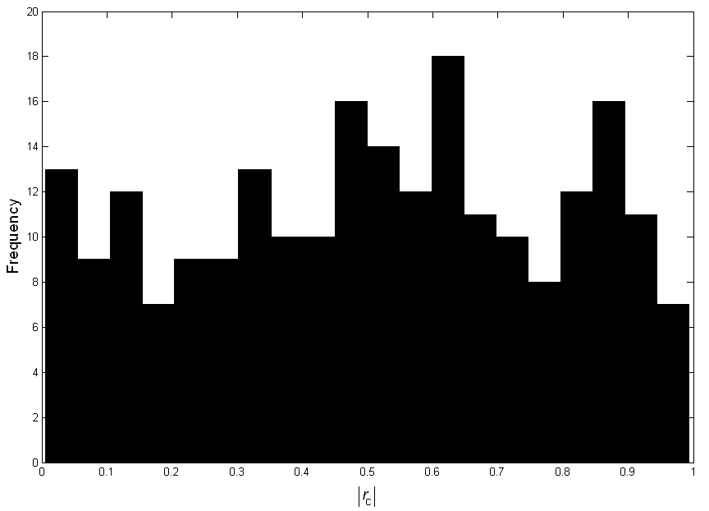
Figure S1. Frequency distribution of the absolute value of the Pearson correlation coefficient r_{c} for independent variables from complete datasets. Three main regions are visible: from 0 to 0.2, from 0.2 to 0.75, and from 0.75 to 1, roughly corresponding to very low to low, medium to high, and very high correlations.

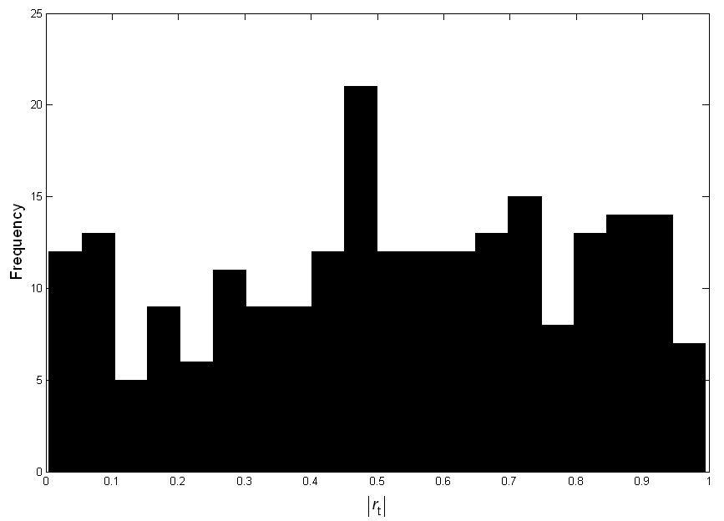
Figure S2. Frequency distribution of the absolute value of the Pearson correlation coefficient r_{t} for independent variables from training datasets. Three main regions are visible: from 0 to 0.15, from 0.15 to 0.75, and from 0.75 to 1, roughly corresponding to very low to low, medium to high, and very high correlations.

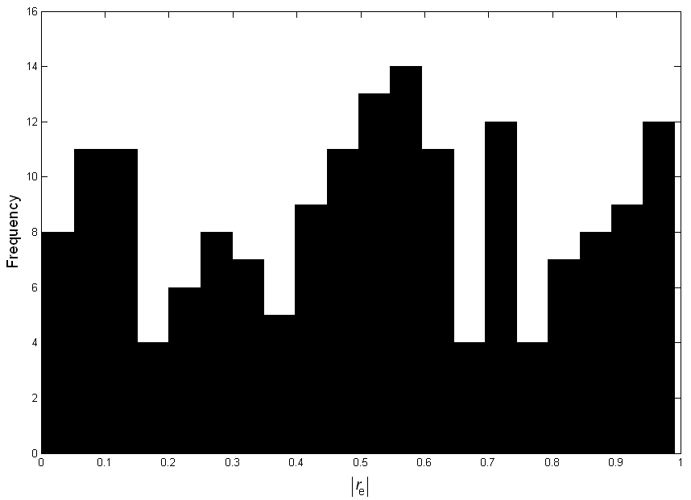

Figure S3. Frequency distribution of the absolute value of the Pearson correlation coefficient r_{e} for independent variables from external validation datasets. Three main regions are visible: from 0 to 0.15, from 0.15 to 0.75 (with three local peaks), and from 0.75 to 1, roughly corresponding to very low to low, medium to high, and very high correlations.

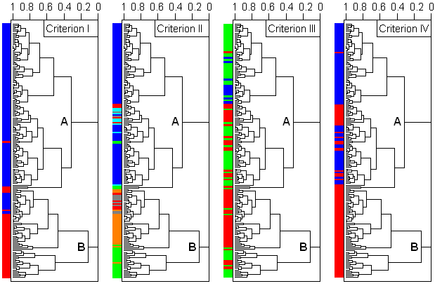

Figure S4. The samples dendogram from the HCA analysis of the four F-functions (F₁, F₂, F₃ and F₄), with classes of descriptors marked in different colors. Criterion I: blue – no sign change, red – sign change present; Criterion II: blue, cyan, green – real, quasi, anti descriptors, respectively, and gray, orange, red – real, unstable, hidden noise, respectively; Criterion III: blue – good, green – acceptable, red – not acceptable x-y scatterplots; Criterion IV: blue – reliable, red – not reliable descriptors.

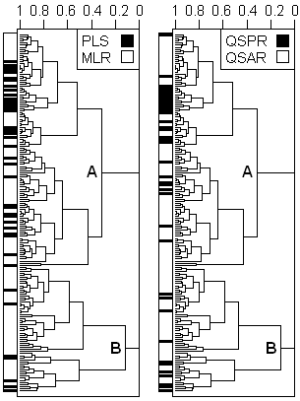

Figure S5. The samples dendogram from the HCA analysis of the four F-functions (F₁, F₂, F₃ and F₄), with distinction of PLS from MLR models, and QSPR from QSAR models.

Comments for Figure S5. This HCA dendrogram was inspected for two more classifications: 1) descriptors from PLS and from MLR models, and 2) descriptors from QSAR/QSAR-like models and from QSPR/QSPR-like models. The classes are not uniformly distributed over clusters A and B and their subclusters. PLS models in one classification and QSPR/QSPR-like models in the other one, although making minorities, tend to be concentrated more in cluster A than in B. Perhaps it reflects the basic distinction between MLR and PLS (use of significant fraction of original descriptors in PLS), and between QSAR and QSPR (the latter does not need frequent transformation of y, and is easier to interpret since corresponding chemical background is simpler).

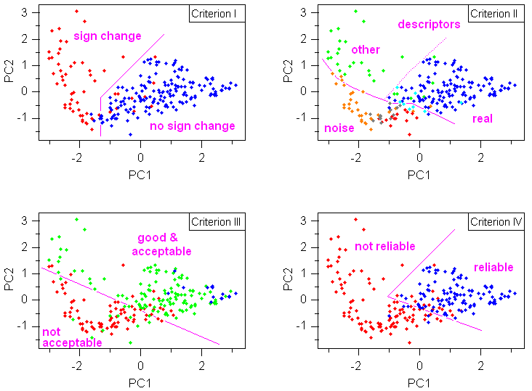

Figure S6. The PC1-PC2 scores plots from the PCA analysis of the three F-functions (F₁, F₃ and F₄), with classes of descriptors marked in different colors and separated by arbitrarily drawn magenta lines. Criterion I: blue – no sign change, red – sign change present; Criterion II: blue, cyan, green – real, quasi, anti descriptors, respectively, and gray, orange, red – real, unstable, hidden noise, respectively; Criterion III: blue – good, green – acceptable, red – not acceptable x-y scatterplots; Criterion IV: blue – reliable, red – not reliable descriptors.

Comments for Figure S6. The three F-functions for 227 descriptors, when explored with PCA, show similar trends as the four F-functions for 174 descriptors. The scores plots (PC1: 78% and PC2: 20% of the original variance) in Figure S6 show somewhat more mixing between classes of variables than in Figure 5.

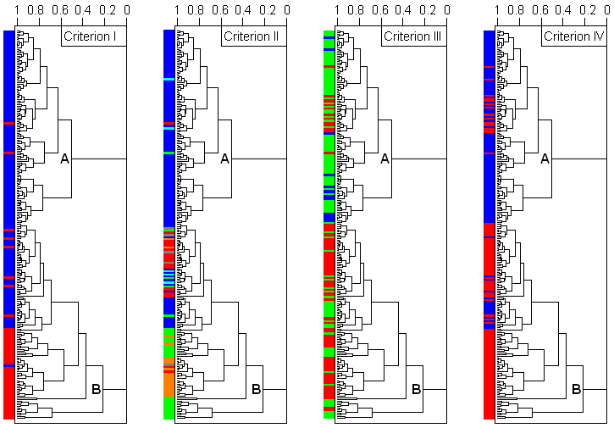

Figure S7. The samples dendogram from the HCA analysis of the three F-functions (F₁, F₃ and F₄), with classes of descriptors marked in different colors. Criterion I: blue – no sign change, red – sign change present; Criterion II: blue, cyan, green – real, quasi, anti descriptors, respectively, and gray, orange, red – real, unstable, hidden noise, respectively; Criterion III: blue – good, green – acceptable, red – not acceptable x-y scatterplots; Criterion IV: blue – reliable, red – not reliable descriptors.

Comments for Figure S7. The three F-functions for 227 descriptors, when explored with HCA, show similar trends as the four F-functions for 174 descriptors. This notable similarity can be seen when comparing dendograms for descriptor accounting for the four classifications in Figures S4 and S8.

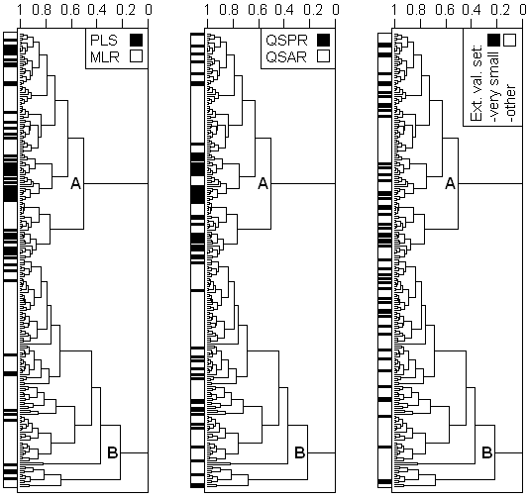

Figure S8. The samples dendogram from the HCA analysis of the three F-functions (F₁, F₃ and F₄), with distinction of PLS from MLR models, QSPR from QSAR models, and small from moderate and large external validation sets (small sets have less than seven samples).

Comments for Figure S8. The three F-functions for 227 descriptors, when explored with HCA, show similar trends as the four F-functions for 174 descriptors. This notable similarity can be seen in dendograms when considering PLS-MLR and QSAR-QSPR distinctions (Figures S5 and S8). This similarity may be due to rather uniform distribution of descriptors from datasets with very small external sets (less than seven samples), as visible in Figure S8 right.

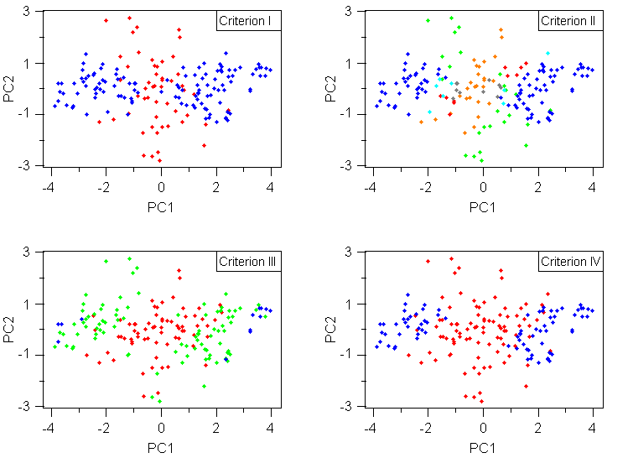

Figure S9. The PC1-PC2 scores plots from the PCA analysis of the five parameters (r_{c}, r_{t}, r_{e}, β_{c} and β_{t}), with classes of descriptors marked in different colors. Criterion I: blue – no sign change, red – sign change present; Criterion II: blue, cyan, green – real, quasi, anti descriptors, respectively, and gray, orange, red – real, unstable, hidden noise, respectively; Criterion III: blue – good, green – acceptable, red – not acceptable x-y scatterplots; Criterion IV: blue – reliable, red – not reliable descriptors.

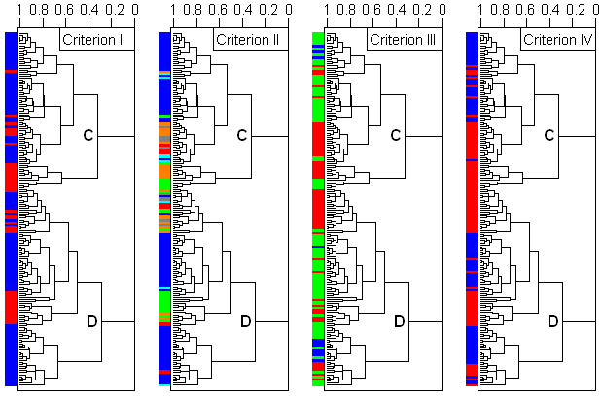

Figure S10. The samples dendogram from the HCA analysis of the five parameters (r_{c}, r_{t}, r_{e}, β_{c} and β_{t}), with classes of descriptors marked in different colors. Criterion I: blue – no sign change, red – sign change present; Criterion II: blue, cyan, green – real, quasi, anti descriptors, respectively, and gray, orange, red – real, unstable, hidden noise, respectively; Criterion III: blue – good, green – acceptable, red – not acceptable x-y scatterplots; Criterion IV: blue – reliable, red – not reliable descriptors.

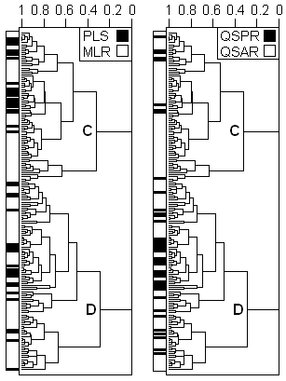

Figure S11. The samples dendogram from the HCA analysis of the five parameters (r_{c}, r_{t}, r_{e}, β_{c} and β_{t}), with distinction of PLS from MLR models, and QSPR from QSAR models.

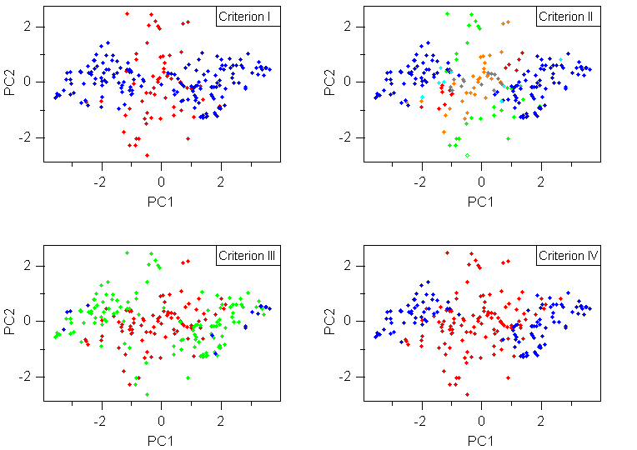

Figure S12. The PC1-PC2 scores plots from the PCA analysis of the four parameters (r_{c}, r_{t}, β_{c} and β_{t}), with classes of descriptors marked in different colors. Criterion I: blue – no sign change, red – sign change present; Criterion II: blue, cyan, green – real, quasi, anti descriptors, respectively, and gray, orange, red – real, unstable, hidden noise, respectively; Criterion III: blue – good, green – acceptable, red – not acceptable x-y scatterplots; Criterion IV: blue – reliable, red – not reliable descriptors.

Comments for Figure S12. The four parameters (r_{c}, r_{t}, β_{c} and β_{t}) for 227 descriptors, when explored with PCA, show similar trends as the five parameters (r_{c}, r_{t}, r_{e}, β_{c} and β_{t}) for 174 descriptor. The scores plots (PC1: 82% and PC2: 17%) in Figure S12 show practically the same trend as the analogous plots in Figure S9.

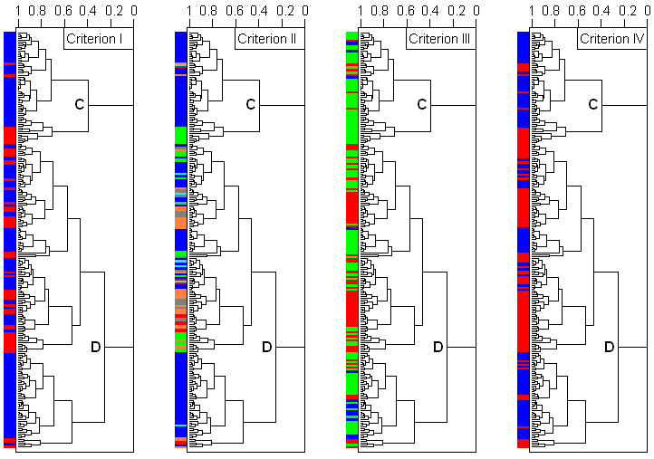

Figure S13. The samples dendogram from the HCA analysis of the four parameters (r_{c}, r_{t}, β_{c} and β_{t}), with classes of descriptors marked in different colors. Criterion I: blue – no sign change, red – sign change present; Criterion II: blue, cyan, green – real, quasi, anti descriptors, respectively, and gray, orange, red – real, unstable, hidden noise, respectively; Criterion III: blue – good, green – acceptable, red – not acceptable x-y scatterplots; Criterion IV: blue – reliable, red – not reliable descriptors.

Comments for Figure S13. The four parameters (r_{c}, r_{t}, β_{c} and β_{t}) for 227 descriptors, when explored with HCA, show similar trends as the five parameters (r_{c}, r_{t}, r_{e}, β_{c} and β_{t}) for 174 descriptor. This notable similarity can be seen when comparing dendograms for descriptor accounting for the four classifications in Figures S10 and S13.

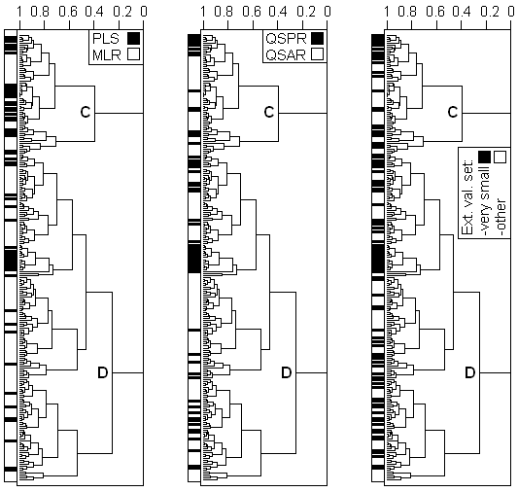

Figure S14. The samples dendogram from the HCA analysis of the four parameters (r_{c}, r_{t}, β_{c} and β_{t}), with distinction of PLS from MLR models, and QSPR from QSAR models, and small from moderate and large external validation sets (small sets have less than seven samples).

Comments for Figure S14. The four parameters (r_{c}, r_{t}, β_{c} and β_{t}) for 227 descriptors, when explored with HCA, show similar trends as the five parameters (r_{c}, r_{t}, r_{e}, β_{c} and β_{t}) for 174 descriptor. This notable similarity can be seen in dendograms when considering PLS-MLR and QSAR-QSPR distinctions (Figures S11 and S14). This similarity may be due to rather uniform distribution of descriptors from datasets with very small external sets (less than seven samples), as visible in Figure S14 right.

Table S3. Bivariate linear regression models of the form $\hat{y}$ = α_{c} + β_{1c} x₁ + β_{2c} x₂ related to the dataset 48.*

Regression | Human Liver (r₁ = 0.7308) |  |  |  | LUMO (r₁ = -0.8367) |  |  |  | N_{O} (r₁ = -0.0429)
No. | β_{1c} | β_{2c} | r₂ | r₁₂ | β_{1c} | β_{2c} | r₂ | r₁₂ | β_{1c} | β_{2c} | r₂ | r₁₂
1 | 0.4350 | -0.9004 | -0.8367 | -0.6752 | -0.9004 | 0.4350 | 0.7308 | -0.6752 | -0.0657 | 0.9978 | 0.7308 | 0.0072
2 | 0.9978 | -0.0657 | -0.0429 | 0.0072 | -0.9637 | -0.2670 | -0.0429 | -0.2290 | -0.2670 | -0.9637 | -0.8367 | -0.2290
3 | 0.9149 | 0.4036 | 0.6165 | 0.6413 | -0.9918 | 0.1275 | 0.6165 | -0.6720 | -0.3608 | 0.9327 | 0.6165 | 0.3260
4 | 0.8827 | 0.4699 | 0.6270 | 0.5994 | -0.9863 | 0.1648 | 0.6270 | -0.6656 | -0.2357 | 0.9718 | 0.6270 | 0.1771
5 | 0.7221 | 0.6918 | 0.7274 | 0.8040 | -0.9661 | 0.2583 | 0.7274 | -0.7842 | -0.3364 | 0.9417 | 0.7274 | 0.3047
6 | 1.0000 | -0.0094 | 0.5187 | 0.7144 | -0.9920 | 0.1265 | 0.5187 | -0.5346 | -0.0051 | 1.0000 | 0.5187 | -0.0777
7 | 0.9986 | 0.0533 | 0.5533 | 0.7334 | -0.9904 | 0.1384 | 0.5533 | -0.5746 | -0.0313 | 0.9995 | 0.5533 | -0.0463
8 | 0.9735 | -0.2288 | -0.6181 | -0.7624 | -0.9999 | -0.0104 | -0.6181 | 0.7340 | -0.2458 | -0.9693 | -0.6181 | -0.1875
9 | 0.9680 | -0.2510 | -0.6270 | -0.7700 | -0.9998 | 0.0202 | -0.6270 | 0.7581 | -0.2788 | -0.9603 | -0.6270 | -0.2264
10 | 0.8680 | -0.4965 | -0.6038 | -0.4823 | -0.9813 | -0.1923 | -0.6038 | 0.6123 | -0.4479 | -0.8941 | -0.6038 | -0.4458
11 | 0.9899 | -0.1420 | -0.2449 | -0.2013 | -0.9989 | -0.0467 | -0.2449 | 0.2493 | -0.5860 | -0.8103 | -0.2449 | -0.6276
13 | 0.8887 | -0.4585 | -0.5566 | -0.4047 | -0.9999 | 0.0153 | -0.5566 | 0.6736 | -0.0092 | -1.0000 | -0.5566 | 0.0679
13 | 0.9963 | -0.0859 | -0.0376 | 0.0350 | -0.9962 | 0.0869 | -0.0376 | 0.1316 | -0.8175 | -0.5759 | -0.0376 | 0.4485
14 | 0.9914 | -0.1309 | 0.3333 | 0.5548 | -0.9995 | 0.0307 | 0.3333 | -0.3722 | -0.2916 | 0.9565 | 0.3333 | 0.1834
15 | 0.6345 | 0.7729 | 0.7502 | 0.7641 | -0.9176 | 0.3974 | 0.7502 | -0.7579 | -0.2741 | 0.9617 | 0.7502 | 0.2316
16 | 0.9998 | 0.0197 | 0.5417 | 0.7322 | -0.9827 | 0.1853 | 0.5417 | -0.5227 | -0.3315 | 0.9435 | 0.5417 | 0.2799
17 | 0.9033 | 0.4291 | 0.5659 | 0.4736 | -0.9859 | 0.1671 | 0.5659 | -0.5725 | -0.5233 | 0.8521 | 0.5659 | 0.5646
18 | 0.6410 | -0.7675 | -0.7654 | -0.5898 | -0.9847 | -0.1744 | -0.7654 | 0.8803 | -0.4104 | -0.9119 | -0.7654 | -0.4043
19 | 0.9594 | 0.2819 | 0.2377 | 0.0347 | -0.9983 | -0.0578 | 0.2377 | -0.3364 | -0.5772 | 0.8166 | 0.2377 | 0.6033
20 | 0.9087 | 0.4174 | 0.6516 | 0.7323 | -0.9937 | 0.1117 | 0.6516 | -0.7303 | -0.4469 | 0.8946 | 0.6516 | 0.4485
21 | 0.9423 | 0.3348 | 0.5145 | 0.4651 | -0.9004 | 0.4350 | 0.7308 | -0.5483 | -0.5040 | 0.8637 | 0.5145 | 0.5257
*The dataset 48 from Table S1, with extension to the full descriptor pool (22 independent variables in total) [31]. The dependent variable is human toxicity HAP. Variable 1 is one of the three descriptors in the final trivariate model for prediction of HAP (see Table S1): Human Liver (human liver toxicity as –logIC₅₀), LUMO or N_{o} (number of oxygen atoms). Descriptor 2 is any other of the 21 variables. Index “c” means complete dataset, i.e., no data split was applied. Regression coefficients β_{1c} and β_{2c} are for descriptors 1 and 2, respectively. Pearson correlation coefficients r₁ and r₂ account for correlation between descriptor 1 and HAP, and descriptor 2 and HAP, respectively. The correlation coefficient r₁₂ is for correlation between descriptors 1 and 2.

Table S4. Multicollinearity effects on multiple linear regression in analytical form.

mª | Linear regressions^{b} | Multiple linear regression^{c} | No multicollinearity^{d} | Multicollinearity present^{e}
1^{f} | $\hat{y}=a+bx$; r; R; R = |r| | – | – | –
2 | $\hat{y}=a_{1}+b_{1}x_{1}$; r₁; R₁  $\hat{y}=a_{2}+b_{2}x_{2}$; r₂; R₂; r₁₂ | $\hat{y}=α+β_{1}x_{1}+β_{2}x_{2}$; R | $$β_{1}=b_{1}=\sqrt{\frac{σ_{y}}{σ_{x1}}}r_{1}$$  $$β_{2}=b_{2}=\sqrt{\frac{σ_{y}}{σ_{x2}}}r_{2}$$  $$α=a_{1}+a_{2}−\overline{y}$$  $$R^{2}=R_{1}^{2}+R_{2}^{2}$$ | $$β_{1}=\sqrt{\frac{σ_{y}}{σ_{x1}}}\frac{r_{1}−r_{2}r_{\text{12}}}{1−r_{\text{12}}^{2}}≠b_{1}$$  $$β_{2}=\sqrt{\frac{σ_{y}}{σ_{x2}}}\frac{r_{2}−r_{1}r_{\text{12}}}{1−r_{\text{12}}^{2}}≠b_{2}$$  $$α=\overline{y}−β_{1}\overline{x_{1}}−β_{2}\overline{x_{2}}≠a_{1}+a_{2}−\overline{y}$$  $$R^{2}<R_{1}^{2}+R_{2}^{2}$$
3 | $\hat{y}=a_{1}+b_{1}x_{1}$; r₁; R₁  $\hat{y}=a_{2}+b_{2}x_{2}$; r₂; R₂; r₁₂  $\hat{y}=a_{3}+b_{3}x_{3}$; r₃; R₃; r₁₃; r₂₃ | $\hat{y}=α+β_{1}x_{1}+β_{2}x_{2}+β_{3}x_{3}$; R | $$β_{1}=b_{1}=\sqrt{\frac{σ_{y}}{σ_{x1}}}r_{1}$$  $$β_{2}=b_{2}=\sqrt{\frac{σ_{y}}{σ_{x2}}}r_{2}$$  $$β_{3}=b_{3}=\sqrt{\frac{σ_{y}}{σ_{x3}}}r_{3}$$  $$α=a_{1}+a_{2}+a_{3}−2\overline{y}$$  $$R^{2}=R_{1}^{2}+R_{2}^{2}+R_{3}^{2}$$ | $$β_{1}=\sqrt{\frac{σ_{y}}{σ_{x1}}}\frac{f_{1}\left(r_{1},r_{2},r_{3},r_{\text{12}},r_{\text{13}},r_{\text{23}}\right)}{g_{1}\left(r_{\text{12}},r_{\text{13}},r_{\text{23}}\right)}≠b_{1}$$  $$β_{2}=\sqrt{\frac{σ_{y}}{σ_{x2}}}\frac{f_{2}\left(r_{1},r_{2},r_{3},r_{\text{12}},r_{\text{13}},r_{\text{23}}\right)}{g_{1}\left(r_{\text{12}},r_{\text{13}},r_{\text{23}}\right)}≠b_{2}$$  $$β_{3}=\sqrt{\frac{σ_{y}}{σ_{x3}}}\frac{f_{3}\left(r_{1},r_{2},r_{3},r_{\text{12}},r_{\text{13}},r_{\text{23}}\right)}{g_{1}\left(r_{\text{12}},r_{\text{13}},r_{\text{23}}\right)}≠b_{3}$$  $α=\overline{y}−β_{1}\overline{x_{1}}−β_{2}\overline{x_{2}}−β_{3}\overline{x_{3}}≠a_{1}+a_{2}+a_{3}−\overline{2y}$  $$R^{2}<R_{1}^{2}+R_{2}^{2}+R_{3}^{2}$$
4 | $\hat{y}=a_{1}+b_{1}x_{1}$; r₁; R₁  $\hat{y}=a_{2}+b_{2}x_{2}$; r₂; R₂; r₁₂; r₁₃  $\hat{y}=a_{3}+b_{3}x_{3}$; r₃; R₃; r₂₃; r₂₄  $\hat{y}=a_{4}+b_{4}x_{4}$; r₄; R₄; r₁₄; r₃₄ | $\hat{y}=α+β_{1}x_{1}+β_{2}x_{2}+β_{3}x_{3}+β_{4}x_{4}$; R | $$β_{1}=b_{1}=\sqrt{\frac{σ_{y}}{σ_{x1}}}r_{1}$$  $$β_{2}=b_{2}=\sqrt{\frac{σ_{y}}{σ_{x2}}}r_{2}$$  $$β_{3}=b_{3}=\sqrt{\frac{σ_{y}}{σ_{x3}}}r_{3}$$  $$β_{4}=b_{4}=\sqrt{\frac{σ_{y}}{σ_{x4}}}r_{4}$$  $$α=a_{1}+a_{2}+a_{3}+a_{4}−3\overline{y}$$  $$R^{2}=R_{1}^{2}+R_{2}^{2}+R_{3}^{2}+R_{4}^{2}$$ | $$β_{1}=\sqrt{\frac{σ_{y}}{σ_{x1}}}\frac{f_{1}\left(r_{1},r_{2},r_{3},r_{4},r_{\text{12}},r_{\text{13}},r_{\text{14}},r_{\text{23}},r_{\text{24}},r_{\text{34}}\right)}{g\left(r_{\text{12}},r_{\text{13}},r_{\text{14}},r_{\text{23}},r_{\text{24}},r_{\text{34}}\right)}≠b_{1}$$  $$β_{2}=\sqrt{\frac{σ_{y}}{σ_{x2}}}\frac{f_{2}\left(r_{1},r_{2},r_{3},r_{4},r_{\text{12}},r_{\text{13}},r_{\text{14}},r_{\text{23}},r_{\text{24}},r_{\text{34}}\right)}{g\left(r_{\text{12}},r_{\text{13}},r_{\text{14}},r_{\text{23}},r_{\text{24}},r_{\text{34}}\right)}≠b_{2}$$  $$β_{3}=\sqrt{\frac{σ_{y}}{σ_{x3}}}\frac{f_{3}\left(r_{1},r_{2},r_{3},r_{4},r_{\text{12}},r_{\text{13}},r_{\text{14}},r_{\text{23}},r_{\text{24}},r_{\text{34}}\right)}{g\left(r_{\text{12}},r_{\text{13}},r_{\text{14}},r_{\text{23}},r_{\text{24}},r_{\text{34}}\right)}≠b_{3}$$  $$β_{4}=\sqrt{\frac{σ_{y}}{σ_{x4}}}\frac{f_{4}\left(r_{1},r_{2},r_{3},r_{4},r_{\text{12}},r_{\text{13}},r_{\text{14}},r_{\text{23}},r_{\text{24}},r_{\text{34}}\right)}{g\left(r_{\text{12}},r_{\text{13}},r_{\text{14}},r_{\text{23}},r_{\text{24}},r_{\text{34}}\right)}≠b_{4}$$  $$α=\overline{y}−β_{1}\overline{x_{1}}−β_{2}\overline{x_{2}}−β_{3}\overline{x_{3}}−β_{4}\overline{x_{4}}≠$$  $$a_{1}+a_{2}+a_{3}+a_{4}−3\overline{y}$$  $$R^{2}<R_{1}^{2}+R_{2}^{2}+R_{3}^{2}+R_{4}^{2}$$
m^{g} | $\hat{y}=a_{j}+b_{j}x_{j}$; r_{j}; R_{j};  j = 1, 2, ..., m;  k = 1, 2, ..., m-1; r_{kl},  m ≥ l ≥ k+1 | $\hat{y}=α+β_{1}x_{1}+β_{2}x_{2}+\text{.}\text{.}\text{.}+β_{m}x_{m}$; R | $$β_{j}=b_{j}=\sqrt{\frac{σ_{y}}{σ_{\text{xj}}}}r_{j}$$  $$α=a_{1}+a_{2}+\text{.}\text{.}\text{.}+a_{m}−\left(m−1\right)\overline{y}$$  $$R^{2}=R_{1}^{2}+R_{2}^{2}+\text{.}\text{.}\text{.}+R_{m}^{2}$$ | $$β_{j}=\sqrt{\frac{σ_{y}}{σ_{\text{xj}}}}\frac{f_{j}\left(r_{1},r_{2},\text{.}\text{.}\text{.},r_{m},r_{\text{12}},r_{\text{13}},\text{.}\text{.}\text{.},r_{m−1,m}\right)}{g\left(r_{\text{12}},r_{\text{13}},\text{.}\text{.}\text{.},r_{m−1,m}\right)}≠b_{j}$$  $$α=\overline{y}−β_{1}\overline{x_{1}}−β_{2}\overline{x_{2}}−\text{.}\text{.}\text{.}−β_{m}\overline{x_{m}}≠$$  $$a_{1}+a_{2}+\text{.}\text{.}\text{.}+a_{m}−\left(m−1\right)\overline{y}$$  $$R^{2}<R_{1}^{2}+R_{2}^{2}+\text{.}\text{.}\text{.}+R_{m}^{2}$$
ªNumber of independent variables (descriptors). For univariate or simple linear regression is m = 1.
^{b}Univariate regressions for all descriptors x₁, x₂, …, x_{m}. The predicted values of the dependent variable y are marked with $\hat{y}$, a₁, a₂, …, a_{m} are the constant coefficients, and b₁, b₂, …, b_{m} are regression coefficients for descriptors x₁, x₂, …, x_{m}, respectively. The Pearson correlation coefficients for correlations between descriptors x₁, x₂, …, x_{m} and y are r₁, r₂, …, r_{m}, respectively, and r₁₂, r₁₃, ..., r_{m-1,m} are correlation coefficients for descriptors’ intercorrelations. R₁, R₂, ..., R_{m} are the coefficients of univariate determinations for descriptors x₁, x₂, …, x_{m}, respectively.
^{c}Multiple linear regression (MLR) for descriptors x₁, x₂, …, x_{m}, and β₁, β₂, …, β_{m} are regression coefficients, respectively, and α is the constant coefficient. R is the coefficients of multiple determinations.
^{d}Expressions for estimated regression coefficients and statistical parameters for MLR, connecting the multivariate with corresponding univariate regressions in the absence of multicollinearity (r₁₂ = r₁₃ = ... = r_{m-1,m} = 0). The average value of y is marked with symbol $\overline{y}$. Standard deviations for y, x₁, x₂, …, x_{m} are σ_{y}, σ_{x1}, σ_{x2}, …, σ_{xm}, respectively.
^{e}Expressions for estimated regression coefficients and statistical parameters for MLR in the presence of multicollinearity, showing significant deviations from the simple relationships between MLR and respective univariate regressions in the absence of multicollinearity. Expressions f₁, f₂, …, f_{m} and g are complicated polynomial functions of Pearson correlation coefficients r₁, r₂, …, r_{m}, and r₁₂, r₁₃, ..., r_{m-1,m}.
^{f}Indices to distinguish regression coefficients and statistical parameters for descriptors are not applicable for univariate regression model as the final model.
^{g}Index j is a general index for m descriptors and m univariate regression equations. Index l accounts for intercorrelations together with the index k.

Comments on Table S4:
Multicollinearity in MLR causes several effects:
1) A regression coefficient is not more a measure of variation of y caused by variation of the corresponding independent variable whilst all other variables are held constant. Its respective regression coefficients in univariate and multivariate regression models are not more equal
2) The sum of coefficients of determination from the corresponding univariate regressions is not equal but is significantly greater than the coefficient of determination of the MLR model, since significant portion of the original variance is repeated in mutually correlated descriptors.

APPENDIX 1: EXPRESSIONS FOR REGRESSION COEFFICIENTS IN MLR WITH 2, 3 AND 4 INDEPENDENT VARIABLES

ESTIMATED PARAMETERS FOR SOME MULTIPLE LINEAR REGRESSIONS (BI-, TRI- AND QUADRIVARIATE)

Legend
x₁, x₂, x₃, x₄ – independent (predictor) variables;
y – observed values of the dependent (response) variable;
$\hat{y}$ – predicted values of the dependent (response) variable;
$\overline{x_{1}}$, $\overline{x_{2}}$, $\overline{x_{3}}$, $\overline{x_{4}}$, $\overline{y}$– average values of x₁, x₂, x₃, x₄ and y, respectively;
α – intercept of the linear regression (hyper)plane from the multivariate regression equation;
β₁, β₂, β₃, β₄ – regression coefficients for x₁, x₂, x₃ and x₄ in multivariate models, respectively;
σ_{y}, σ_{x1}, σ_{x2}, σ_{x3}, σ_{x4} – standard deviations of y, x₁, x₂, x₃ and x₄, respectively;
r₁, r₂, r₃, r₄ – Pearson correlation coefficients for pairs of variables (x₁, y), (x₂, y), (x₃, y) and (x₄, y), respectively;
r₁₂, r₁₃, r₁₄, r₂₃, r₂₄, r₃₄ – Pearson correlation coefficients for pairs of variables (x₁, x₂), (x₁, x₃), (x₁, x₄), (x₂, x₃), (x₂, x₄) and (x₃, x₄), respectively.

Note.
Expressions for regression coefficients were derived from expressions for normal equations. The following literature was used:
-examples of deriving β₁ and β₂ in bivariate regression [Janke, S. J.; Tinsley, F. C. Introduction to Linear Models and Statistical Inference. Wiley: Hoboken, NJ, 2005, p 354; Kutner, M. H.; Nachtsheim, C. J.; Neter, J.; Li, W. Applied Linear Statistical Models, 5th ed. McGraw-Hill: Boston, MA, 2005, p. 276.];
-expressions for inverse matrices of dimensions 2×2, 3×3 and 4×4 [Inverse matrix of 2-by-2 matrix, 3-by-3 matrix, 4-by-4 matrix. The site of D. Miyazaki at the University of Tokyo, accessed on October 9, 2009. http://www.cvl.iis.u-tokyo.ac.jp/~miyazaki/tech/teche23.html];
-general information about Laplace expansion in matrix inversion [Laplace expansion. Wikipedia - the free encyclopedia. Wikimedia Foundations, San Francisco, CA. Accessed on October 8, 2009. http://en.wikipedia.org/wiki/Laplace_expansion].
BIVARIATE LINEAR REGRESSION

$$\hat{y}=α+β_{1}x_{1}+β_{2}x_{2}$$

$$α=\overline{y}−β_{1}\overline{x_{1}}−β_{2}\overline{x_{2}}$$

$$β_{1}=\sqrt{\frac{σ_{y}}{σ_{x1}}}\frac{r_{1}−r_{2}r_{\text{12}}}{1−r_{\text{12}}^{2}}$$

$$β_{2}=\sqrt{\frac{σ_{y}}{σ_{x2}}}\frac{r_{2}−r_{1}r_{\text{12}}}{1−r_{\text{12}}^{2}}$$

TRIVARIATE LINEAR REGRESSION

$$\hat{y}=α+β_{1}x_{1}+β_{2}x_{2}+β_{3}x_{3}$$

$$α=\overline{y}−β_{1}\overline{x_{1}}−β_{2}\overline{x_{2}}−β_{3}\overline{x_{3}}$$

$$β_{1}=\sqrt{\frac{σ_{y}}{σ_{x1}}}\frac{r_{1}\left(1−r_{\text{23}}^{2}\right)+r_{2}\left(r_{\text{13}}r_{\text{23}}−r_{\text{12}}\right)+r_{3}\left(r_{\text{12}}r_{\text{23}}−r_{\text{13}}\right)}{1+2r_{\text{12}}r_{\text{13}}r_{\text{23}}−r_{\text{12}}^{2}−r_{\text{13}}^{2}−r_{\text{23}}^{2}}$$

$$β_{2}=\sqrt{\frac{σ_{y}}{σ_{x2}}}\frac{r_{1}\left(r_{\text{13}}r_{\text{23}}−r_{\text{12}}\right)+r_{1}\left(1−r_{\text{13}}^{2}\right)+r_{3}\left(r_{\text{12}}r_{\text{13}}−r_{\text{23}}\right)}{1+2r_{\text{12}}r_{\text{13}}r_{\text{23}}−r_{\text{12}}^{2}−r_{\text{13}}^{2}−r_{\text{23}}^{2}}$$

$$β_{3}=\sqrt{\frac{σ_{y}}{σ_{x3}}}\frac{r_{1}\left(r_{\text{12}}r_{\text{23}}−r_{\text{13}}\right)+r_{2}\left(r_{\text{12}}r_{\text{13}}−r_{\text{23}}\right)+r_{3}\left(1−r_{\text{12}}^{2}\right)}{1+2r_{\text{12}}r_{\text{13}}r_{\text{23}}−r_{\text{12}}^{2}−r_{\text{13}}^{2}−r_{\text{23}}^{2}}$$

QUADRIVARIATE LINEAR REGRESSION

$$\hat{y}=α+β_{1}x_{1}+β_{2}x_{2}+β_{3}x_{3}+β_{4}x_{4}$$

$$α=\overline{y}−β_{1}\overline{x_{1}}−β_{2}\overline{x_{2}}−β_{3}\overline{x_{3}}−β_{4}\overline{x_{4}}$$

$$β_{1}=\sqrt{\frac{σ_{y}}{σ_{x2}}}\left\{r_{1}\left(1+2r_{\text{23}}r_{\text{24}}r_{\text{34}}−r_{\text{23}}^{2}−r_{\text{24}}^{2}−r_{\text{34}}^{2}\right)+r_{2}\left[r_{\text{12}}\left(r_{\text{34}}^{2}−1\right)+r_{\text{13}}\left(r_{\text{23}}−r_{\text{24}}r_{\text{34}}\right)+r_{\text{14}}\left(r_{\text{24}}−r_{\text{23}}r_{\text{34}}\right)\right]+r_{3}\left[r_{\text{13}}\left(r_{\text{34}}^{2}−1\right)+r_{\text{12}}\left(r_{\text{23}}−r_{\text{24}}r_{\text{34}}\right)+r_{\text{14}}\left(r_{\text{34}}−r_{\text{23}}r_{\text{24}}\right)\right]\right.+$$
$$+\left.r_{4}\left[r_{\text{14}}\left(r_{\text{33}}^{2}−1\right)+r_{\text{12}}\left(r_{\text{24}}−r_{\text{23}}r_{\text{34}}\right)+r_{\text{13}}\left(r_{\text{34}}−r_{\text{23}}r_{\text{24}}\right)\right]\right\}/\left\{1+2r_{\text{12}}r_{\text{13}}r_{\text{23}}+2r_{\text{12}}r_{\text{14}}r_{\text{24}}+2r_{\text{13}}r_{\text{14}}r_{\text{34}}+2r_{\text{23}}r_{\text{24}}r_{\text{34}}−r_{\text{12}}^{2}r_{\text{34}}^{2}−r_{\text{13}}^{2}r_{\text{24}}^{2}−r_{\text{14}}^{2}r_{\text{23}}^{2}−\right.$$
$$\left.−2r_{\text{12}}r_{\text{13}}r_{\text{23}}r_{\text{34}}−2r_{\text{12}}r_{\text{14}}r_{\text{24}}r_{\text{34}}−2r_{\text{13}}r_{\text{14}}r_{\text{23}}r_{\text{34}}−r_{\text{13}}^{2}−r_{\text{14}}^{2}−r_{\text{23}}^{2}−r_{\text{24}}^{2}−r_{\text{34}}^{2}\right\}$$

$$β_{2}=\sqrt{\frac{σ_{y}}{σ_{x2}}}\left\{r_{1}\left[r_{\text{12}}\left(r_{\text{34}}^{2}−1\right)+r_{\text{13}}\left(r_{\text{23}}−r_{\text{24}}r_{\text{34}}\right)+r_{\text{14}}\left(r_{\text{24}}−r_{\text{23}}r_{\text{34}}\right)\right]+r_{2}\left(1+2r_{\text{13}}r_{\text{14}}r_{\text{34}}−r_{\text{13}}^{2}−r_{\text{14}}^{2}−r_{\text{34}}^{2}\right)+r_{3}\left[r_{\text{23}}\left(r_{\text{14}}^{2}−1\right)+r_{\text{12}}\left(r_{\text{13}}−r_{\text{14}}r_{\text{34}}\right)+r_{\text{24}}\left(r_{\text{34}}−r_{\text{12}}r_{\text{14}}\right)\right]\right.+$$
$$+\left.r_{4}\left[r_{\text{24}}\left(r_{\text{13}}^{2}−1\right)+r_{\text{12}}\left(r_{\text{14}}−r_{\text{13}}r_{\text{34}}\right)+r_{\text{23}}\left(r_{\text{34}}−r_{\text{13}}r_{\text{14}}\right)\right]\right\}/\left\{1+2r_{\text{12}}r_{\text{13}}r_{\text{23}}+2r_{\text{12}}r_{\text{14}}r_{\text{24}}+2r_{\text{13}}r_{\text{14}}r_{\text{34}}+2r_{\text{23}}r_{\text{24}}r_{\text{34}}−r_{\text{12}}^{2}r_{\text{34}}^{2}−r_{\text{13}}^{2}r_{\text{24}}^{2}−r_{\text{14}}^{2}r_{\text{23}}^{2}−\right.$$
$$\left.−2r_{\text{12}}r_{\text{13}}r_{\text{23}}r_{\text{34}}−2r_{\text{12}}r_{\text{14}}r_{\text{24}}r_{\text{34}}−2r_{\text{13}}r_{\text{14}}r_{\text{23}}r_{\text{34}}−r_{\text{13}}^{2}−r_{\text{14}}^{2}−r_{\text{23}}^{2}−r_{\text{24}}^{2}−r_{\text{34}}^{2}\right\}$$

$$β_{3}=\sqrt{\frac{σ_{y}}{σ_{x3}}}\left\{r_{1}\left[r_{\text{13}}\left(r_{\text{24}}^{2}−1\right)+r_{\text{14}}\left(r_{\text{34}}−r_{\text{23}}r_{\text{24}}\right)+r_{\text{12}}\left(r_{\text{23}}−r_{\text{24}}r_{\text{34}}\right)\right]+r_{2}\left[r_{\text{23}}\left(r_{\text{14}}^{2}−1\right)+r_{\text{12}}\left(r_{\text{13}}−r_{\text{14}}r_{\text{34}}\right)+r_{\text{24}}\left(r_{\text{34}}−r_{\text{12}}r_{\text{24}}\right)\right]+r_{3}\left(1+2r_{\text{12}}r_{\text{14}}r_{\text{24}}−r_{\text{12}}^{2}−r_{\text{14}}^{2}−r_{\text{24}}^{2}\right)\right.+$$
$$+\left.r_{4}\left[r_{\text{34}}\left(r_{\text{12}}^{2}−1\right)+r_{\text{23}}\left(r_{\text{24}}−r_{\text{12}}r_{\text{14}}\right)+r_{\text{13}}\left(r_{\text{14}}−r_{\text{12}}r_{\text{24}}\right)\right]\right\}/\left\{1+2r_{\text{12}}r_{\text{13}}r_{\text{23}}+2r_{\text{12}}r_{\text{14}}r_{\text{24}}+2r_{\text{13}}r_{\text{14}}r_{\text{34}}+2r_{\text{23}}r_{\text{24}}r_{\text{34}}−r_{\text{12}}^{2}r_{\text{34}}^{2}−r_{\text{13}}^{2}r_{\text{24}}^{2}−r_{\text{14}}^{2}r_{\text{23}}^{2}−\right.$$
$$\left.−2r_{\text{12}}r_{\text{13}}r_{\text{23}}r_{\text{34}}−2r_{\text{12}}r_{\text{14}}r_{\text{24}}r_{\text{34}}−2r_{\text{13}}r_{\text{14}}r_{\text{23}}r_{\text{34}}−r_{\text{13}}^{2}−r_{\text{14}}^{2}−r_{\text{23}}^{2}−r_{\text{24}}^{2}−r_{\text{34}}^{2}\right\}$$

$$β_{4}=\sqrt{\frac{σ_{y}}{σ_{x4}}}\left\{r_{1}\left[r_{\text{14}}\left(r_{\text{23}}^{2}−1\right)+r_{\text{12}}\left(r_{\text{24}}−r_{\text{23}}r_{\text{24}}\right)+r_{\text{13}}\left(r_{\text{34}}−r_{\text{23}}r_{\text{24}}\right)\right]+r_{2}\left[r_{\text{24}}\left(r_{\text{13}}^{2}−1\right)+r_{\text{12}}\left(r_{\text{14}}−r_{\text{13}}r_{\text{34}}\right)+r_{\text{23}}\left(r_{\text{34}}−r_{\text{13}}r_{\text{14}}\right)\right]+r_{3}\left[r_{\text{34}}\left(r_{\text{12}}^{2}−1\right)+r_{\text{24}}\left(r_{\text{23}}−r_{\text{12}}r_{\text{13}}\right)+r_{\text{14}}\left(r_{\text{13}}−r_{\text{12}}r_{\text{23}}\right)\right]\right.+$$
$$+\left.r_{4}\left(1+2r_{\text{12}}r_{\text{13}}r_{\text{23}}−r_{\text{12}}^{2}−r_{\text{13}}^{2}−r_{\text{23}}^{2}\right)\right\}/\left\{1+2r_{\text{12}}r_{\text{13}}r_{\text{23}}+2r_{\text{12}}r_{\text{14}}r_{\text{24}}+2r_{\text{13}}r_{\text{14}}r_{\text{34}}+2r_{\text{23}}r_{\text{24}}r_{\text{34}}−r_{\text{12}}^{2}r_{\text{34}}^{2}−r_{\text{13}}^{2}r_{\text{24}}^{2}−r_{\text{14}}^{2}r_{\text{23}}^{2}−\right.$$
$$\left.−2r_{\text{12}}r_{\text{13}}r_{\text{23}}r_{\text{34}}−2r_{\text{12}}r_{\text{14}}r_{\text{24}}r_{\text{34}}−2r_{\text{13}}r_{\text{14}}r_{\text{23}}r_{\text{34}}−r_{\text{13}}^{2}−r_{\text{14}}^{2}−r_{\text{23}}^{2}−r_{\text{24}}^{2}−r_{\text{34}}^{2}\right\}$$

APPENDIX 2: EXPRESSIONS FOR REGRESSION COEFFICIENTS IN PLS WITH 2 INDEPENDENT VARIABLES

Legend
x₁, x₂ – vectors of independent (predictor) variables;
X – matrix of the independent variables, where the first column contains x₁, and the second x₂:
$$X=\left[\begin{matrix}x_{\text{11}} & x_{\text{12}} \\ x_{\text{21}} & x_{\text{22}} \\ \text{.}\text{.}\text{.} & \text{.}\text{.}\text{.} \\ x_{m1} & x_{m2}\end{matrix}\right]$$

y – vector of the observed values of the dependent (response) variable:
$$y=\left[\begin{matrix}y_{1} \\ y_{2} \\ \text{.}\text{.}\text{.} \\ y_{m}\end{matrix}\right]$$

n – number of observations (samples);
y_{i} – i-th element of vector y;
x_{i1} – i-th element of the first column of matrix X, i.e., i-th element of independent variable x₁;
x_{i2} – i-th element of the second column of matrix X, i.e., i-th element of independent variable x₂;
β₁, β₂ – regression coefficients for x₁ and x₂ in the bivariate PLS models, respectively;
r₁, r₂ – Pearson correlation coefficients for pairs of variables (x₁, y) and (x₂, y), respectively;
r₁₂ – Pearson correlation coefficients for the pair of variables (x₁, x₂).

Note 1.
Data X and y are autoscaled, i.e., scaled to unit variance, and therefore, the following equalities are used:

$\sum_{i=1}^{n}{y_{i}^{2}}=1$ $\sum_{i=1}^{n}{x_{i1}^{2}}=1$ $\sum_{i=1}^{n}{x_{i2}^{2}}=1$

$\sum_{i=1}^{n}{x_{i1}y_{i}}=r_{1}$ $\sum_{i=1}^{n}{x_{i2}y_{i}}=r_{2}$ $\sum_{i=1}^{n}{x_{i1}x_{i2}}=r_{\text{12}}$

Note.
Expressions for regression coefficients were derived for the PLS model with one latent variable. The PLS algorithm of Geladi and Kowalski was used to derive these expressions:
Geladi, P.; Kowalski, B. R. Partial least-squares: a tutorial. Anal. Chim. Acta 1986, 185, 1-17.

Algorithm step 1 - Calculation of w:
$$w={\left(y^{T}y\right)}^{−1}X^{T}y$$
$y^{T}y=1$ and $X^{T}y=\left[\begin{matrix}r_{1} \\ r_{2}\end{matrix}\right]$ give $w=\left[\begin{matrix}r_{1} \\ r_{2}\end{matrix}\right]$

Algorithm step 2 - Calculation of w₁, the first column of matrix W:
$$w_{1}={\left(w^{T}w\right)}^{{−1}/2}w$$
$w^{T}w=r_{1}^{2}+r_{2}^{2}$ and $w=\left[\begin{matrix}r_{1} \\ r_{2}\end{matrix}\right]$ give $w_{1}=\left[\begin{matrix}w_{\text{11}} \\ w_{\text{21}}\end{matrix}\right]=\frac{1}{\sqrt{r_{1}^{2}+r_{2}^{2}}}\left[\begin{matrix}r_{1} \\ r_{2}\end{matrix}\right]$

Algorithm step 3 - Calcultion of t₁, the first column of matrix T:
$$t_{1}={\text{Xw}}_{1}$$
$X=\left[\begin{matrix}x_{\text{11}} & x_{\text{12}} \\ x_{\text{21}} & x_{\text{22}} \\ \text{.}\text{.}\text{.} & \text{.}\text{.}\text{.} \\ x_{m1} & x_{m2}\end{matrix}\right]$ and $w_{1}=\frac{1}{\sqrt{r_{1}^{2}+r_{2}^{2}}}\left[\begin{matrix}r_{1} \\ r_{2}\end{matrix}\right]$ give $t_{1}=\left[\begin{matrix}t_{\text{11}} \\ t_{\text{21}} \\ \text{.}\text{.}\text{.} \\ t_{m1}\end{matrix}\right]=\frac{1}{\sqrt{r_{1}^{2}+r_{2}^{2}}}\left[\begin{matrix}x_{\text{11}}r_{1}+x_{\text{12}}r_{2} \\ x_{\text{21}}r_{1}+x_{\text{22}}r_{2} \\ \text{.}\text{.}\text{.} \\ x_{m1}r_{1}+x_{m2}r_{2}\end{matrix}\right]$

Algorithm step 4 - Calculation of q₁, the first element of line vector q:
$$q_{1}={\left(t_{1}^{T}t_{1}\right)}^{−1}t_{1}^{T}y$$
$t_{1}^{T}t_{1}=\frac{{\left(x_{\text{11}}r_{1}+x_{\text{12}}r_{2}\right)}^{2}+{\left(x_{\text{21}}r_{1}+x_{\text{22}}r_{2}\right)}^{2}+\text{.}\text{.}\text{.}+{\left(x_{m1}r_{1}+x_{m2}r_{2}\right)}^{2}}{r_{1}^{2}+r_{2}^{2}}=\frac{r_{1}^{2}+r_{2}^{2}+2r_{1}r_{2}r_{\text{12}}}{r_{1}^{2}+r_{2}^{2}}$ and
$t_{1}^{T}y=\frac{y_{1}\left(x_{\text{11}}r_{1}+x_{\text{12}}r_{2}\right)+y_{2}\left(x_{\text{21}}r_{1}+x_{\text{22}}r_{2}\right)+\text{.}\text{.}\text{.}+y_{m}\left(x_{m1}r_{1}+x_{m2}r_{2}\right)}{\sqrt{r_{1}^{2}+r_{2}^{2}}}=\sqrt{r_{1}^{2}+r_{2}^{2}}$ give
$$q_{1}=\sqrt{r_{1}^{2}+r_{2}^{2}}\frac{r_{1}^{2}+r_{2}^{2}}{r_{1}^{2}+r_{2}^{2}+2r_{1}r_{2}r_{\text{12}}}$$

Algorithm step 5 - Calculation of l₁, the first column of matrix L:
$$l_{1}={\left(t_{1}^{T}t_{1}\right)}^{−1}X^{T}t_{1}$$
$t_{1}^{T}t_{1}=\frac{r_{1}^{2}+r_{2}^{2}+2r_{1}r_{2}r_{\text{12}}}{r_{1}^{2}+r_{2}^{2}}$ and $X^{T}t_{1}=\frac{1}{\sqrt{r_{1}^{2}+r_{2}^{2}}}\left[\begin{matrix}x_{\text{11}}\left(x_{\text{11}}r_{1}+x_{\text{12}}r_{2}\right)+x_{\text{21}}\left(x_{\text{21}}r_{1}+x_{\text{22}}r_{2}\right)+\text{.}\text{.}\text{.}+x_{m1}\left(x_{m1}r_{1}+x_{m2}r_{2}\right) \\ x_{\text{12}}\left(x_{\text{11}}r_{1}+x_{\text{12}}r_{2}\right)+x_{\text{22}}\left(x_{\text{21}}r_{1}+x_{\text{22}}r_{2}\right)+\text{.}\text{.}\text{.}+x_{m2}\left(x_{m1}r_{1}+x_{m2}r_{2}\right)\end{matrix}\right]=\frac{1}{\sqrt{r_{1}^{2}+r_{2}^{2}}}\left[\begin{matrix}r_{1}+r_{2}r_{\text{12}} \\ r_{1}r_{\text{12}}+r_{2}\end{matrix}\right]$ give
$$l_{1}=\left[\begin{matrix}l_{\text{11}} \\ l_{\text{21}}\end{matrix}\right]=\sqrt{r_{1}^{2}+r_{2}^{2}}\left[\begin{matrix}\frac{r_{1}+r_{2}r_{\text{12}}}{r_{1}^{2}+r_{2}^{2}+2r_{1}r_{2}r_{\text{12}}} \\ \\ \frac{r_{1}r_{\text{12}}+r_{2}}{r_{1}^{2}+r_{2}^{2}+2r_{1}r_{2}r_{\text{12}}}\end{matrix}\right]$$

Algorithm step 6 - Calculation of the regression vector β:
$$β=w_{1}{\left(l_{1}^{T}w_{1}\right)}^{−1}q_{1}$$
$$β=\left[\begin{matrix}β_{1} \\ β_{2}\end{matrix}\right]=\frac{q_{1}}{l_{\text{11}}w_{\text{11}}+l_{\text{21}}w_{\text{21}}}\left[\begin{matrix}w_{\text{11}} \\ w_{\text{21}}\end{matrix}\right]=\left[\begin{matrix}\frac{r_{1}\left(r_{1}^{2}+r_{2}^{2}\right)}{r_{1}^{2}+r_{2}^{2}+2r_{1}r_{2}r_{\text{12}}} \\ \\ \frac{r_{2}\left(r_{1}^{2}+r_{2}^{2}\right)}{r_{1}^{2}+r_{2}^{2}+2r_{1}r_{2}r_{\text{12}}}\end{matrix}\right]$$

$β_{1}=\frac{r_{1}\left(r_{1}^{2}+r_{2}^{2}\right)}{r_{1}+r_{2}+r_{1}r_{2}r_{\text{12}}^{2}}$ $β_{2}=\frac{r_{2}\left(r_{1}^{2}+r_{2}^{2}\right)}{r_{1}+r_{2}+r_{1}r_{2}r_{\text{12}}^{2}}$

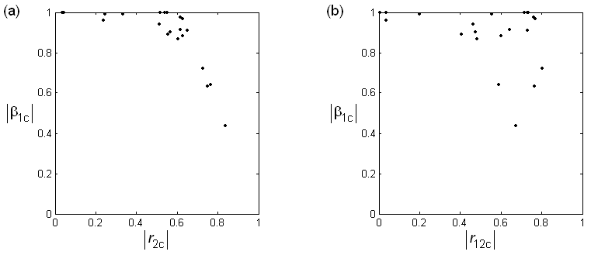

Figure S15. Descriptors’ stability in terms of |β_{1c}| plotted against a) |r_{2c}| and b) |r_{12c}| for all bivariate regressions generated from the complete descriptors pool for the dataset 48. Descriptor 1 is Human Liver from the final model for prediction of human toxicity HAP (Reference No. 44 associated to Table S1). Index 1 stand for the descriptor 1, index 2 for other descriptors, and 12 for intercorrelation between descriptors 1 and 2.

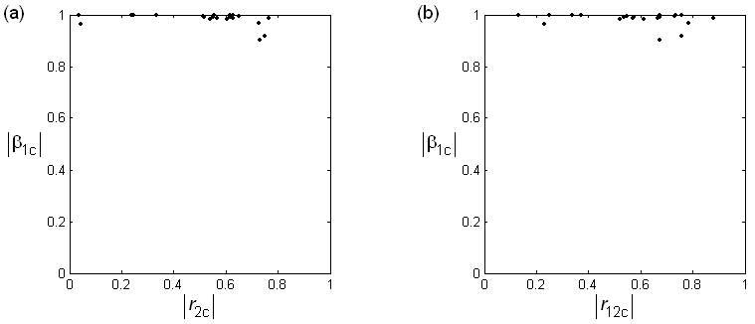

Figure S16. Descriptors’ stability in terms of |β_{1c}| plotted against a) |r_{2c}| and b) |r_{12c}| for all bivariate regressions generated from the complete descriptors pool for the dataset 48. Descriptors 1 is LUMO from the final model for prediction of human toxicity HAP (Reference No. 44 associated to Table S1). Index 1 stand for the descriptor 1, index 2 for other descriptors, and 12 for intercorrelation between descriptors 1 and 2.

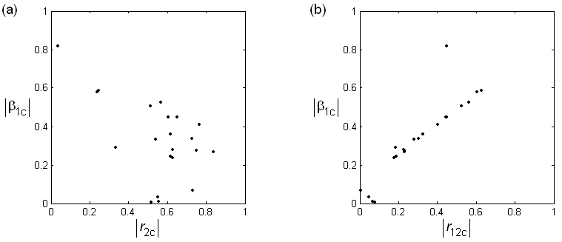

Figure S17. Descriptors’ stability in terms of |β_{1c}| plotted against a) |r_{2c}| and b) |r_{12c}| for all bivariate regressions generated from the complete descriptors pool for the dataset 48. Descriptors 1 is N_{O} from the final model for prediction of human toxicity HAP (Reference No. 44 associated to Table S1). Index 1 stand for the descriptor 1, index 2 for other descriptors, and 12 for intercorrelation between descriptors 1 and 2.

Table S5. Parameters for assessment of PLS overfitting for eight datasetsª.

Parameter^{b} | Dataset | N_{LV} =1 | N_{LV} =2 | N_{LV} =3 | N_{LV} =4 | N_{LV} =5 | N_{LV} =6 | N_{LV} =7 | N_{LV} =8 | N_{LV} =9
$$\overline{F_{3}}$$ | 2 | 0.4686 | 0.3883 | 0.2874 | 0.2315 | 0.1844 | 0.1843 | 0.1002 | 0.0726 | -
 | 3 | 0.5582 | 0.4932 | 0.4932 | 0.3102 | 0.2261 | 0.1960 | 0.1403 | 0.1392 | -
 | 5 | 0.5516 | 0.4496 | 0.1772 | 0.0961 | 0.0676 | 0.0584 | 0.0729 | 0.0878 | -
 | 8 | 0.5090 | 0.5104 | 0.5026 | 0.4561 | 0.4323 | - | - | - | -
 | 11 | 0.5495 | 0.5409 | 0.5339 | 0.5337 | 0.5337 | - | - | - | -
 | 14 | 0.6985 | 0.6365 | 0.6230 | - | - | - | - | - | -
 | 15 | 0.4673 | 0.2991 | 0.3093 | 0.3013 | 0.2869 | 0.2653 | 0.2626 | 0.0186 | 0.0390
 | 18 | 0.6081 | 0.5063 | 0.2833 | - | - | - | - | - | -
w₃ | 2 | 0.0000 | 0.0000 | 0.0019 | 0.1339 | 0.4137 | 0.4149 | 0.3421 | 0.2896 | -
 | 3 | 0.0000 | 0.0000 | 0.0000 | 0.0108 | 0.1621 | 0.2866 | 0.6168 | 0.6033 | -
 | 5 | 0.0000 | 0.0000 | 0.1454 | 0.2756 | 0.2743 | 0.3027 | 0.3557 | 0.5390 | -
 | 8 | 0.0000 | 0.0000 | 0.0000 | 0.0000 | 0.0000 | - | - | - | -
 | 11 | 0.0000 | 0.0000 | 0.0000 | 0.0000 | 0.0000 | - | - | - | -
 | 14 | 0.0000 | 0.0000 | 0.0000 | - | - | - | - | - | -
 | 15 | 0.0000 | 0.0021 | 0.0001 | 0.0060 | 0.0081 | 0.0201 | 0.1344 | 0.3885 | 0.5235
 | 18 | 0.0000 | 0.0004 | 0.0084 | - | - | - | - | - | -
N₃ | 2 | 0 | 0 | 2 | 2 | 2 | 2 | 3 | 3 | -
 | 3 | 0 | 0 | 0 | 3 | 3 | 2 | 2 | 2 | -
 | 5 | 0 | 0 | 3 | 3 | 4 | 4 | 4 | 3 | -
 | 8 | 0 | 0 | 0 | 0 | 0 | - | - | - | -
 | 11 | 0 | 0 | 0 | 0 | 0 | - | - | - | -
 | 14 | 0 | 0 | 0 | - | - | - | - | - | -
 | 15 | 0 | 2 | 1 | 1 | 2 | 2 | 2 | 3 | 3
 | 18 | 0 | 1 | 1 | - | - | - | - | - | -
ªComplete datasets which were used in the literature to build PLS regression models, defined in Table S1 under numbers 2, 3, 5, 8, 11, 14, 15 and 18.
^{b}Three parameters calculated as functions of the number of latent variables (N_{LV}): $\overline{F_{3}}$ - average F₃-function for a model, defined as the sum of F₃-function values for all descriptors in a model, divided by the number of these descriptors (m); w₃ - contribution of the sign-changed coefficients, defined as the sum of squares of regression coefficients β_{c} for descriptors which show the sign change (i.e., their respective F₃-function values are negative); N₃ - number of these descriptors with the sign change problem. The sign change problem was considered as existing only with respect to the sign of $\overline{F_{3}}$. Values typed in bold are for the numbers of latent variables of the final PLS models in original publications (see references after Table S1).

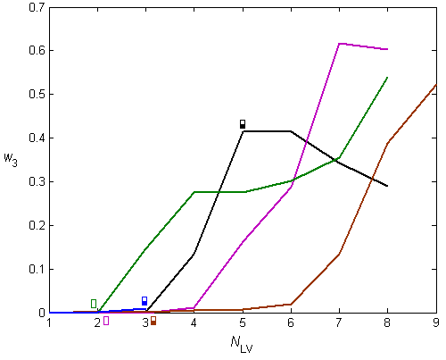

Figure S18. The contribution of the sign-changed coefficients w₃ as a function of the number of latent variables (N_{LV}) for the eight PLS datasets colored differently (2 – black, 3 – magenta, 5 – green, 8 – red, 11 – cyan, 14 – gray, 15 – brown and 18 – blue). N_{LV} for the published PLS models (see Table 1) is marked with small rectangular boxes, which are semi-solid if the sign change has been detected.

Comments on Figure S18:
Five out of eight datasets (2, 3, 5, 15 and 18) have non-zero contribution of the sign-changed coefficients w₃, i.e., the sign change problem has been identified. When this parameter is plotted as a function of the number of latent varibles (N_{LV}), its increasing trend is visible, even a very small increase for dataset 18 can noticed. The extent of this increase can be even up to values around 0.6, meaning that the contribution of the sign-changed regression coefficients is around 60%, what is an obvious consequence of overfitting.

Table S6. Parameters for assessment of the sign change problem for all 50 datasets.

Datasetª | m^{b} | $\overline{F_{3}}$^{c} | $\overline{F_{4}}$^{d} | w₃e | w₄^{f} | N₃^{g} | N₄^{h} | w_{m3}^{i} | w_{m4}^{j}
1 | 5 | 0.2006 | 0.2094 | 0.0026 | 0.0177 | 2 | 2 | 0.4000 | 0.4000
2 | 8 | 0.1844 | 0.1868 | 0.4137 | 0.4097 | 2 | 2 | 0.2500 | 0.2500
3 | 8 | 0.4932 | 0.4823 | 0 | 0 | 0 | 0 | 0 | 0
4 | 3 | 0.4366 | 0.4389 | 0 | 0 | 0 | 0 | 0 | 0
5 | 8 | 0.4496 | 0.4652 | 0 | 0 | 0 | 0 | 0 | 0
6 | 3 | 0.5187 | 0.5225 | 0 | 0 | 0 | 0 | 0 | 0
7 | 8 | 0.1010 | 0.1033 | 0.5717 | 0.5654 | 2 | 2 | 0.2500 | 0.2500
8 | 6 | 0.5026 | 0.5069 | 0 | 0 | 0 | 0 | 0 | 0
9 | 4 | 0.1437 | 0.1367 | 0.2322 | 0.2344 | 2 | 2 | 0.5000 | 0.5000
10 | 5 | 0.2490 | 0.2488 | 0.0243 | 0.0227 | 1 | 1 | 0.2000 | 0.2000
11 | 5 | 0.5495 | 0.5499 | 0 | 0 | 0 | 0 | 0 | 0
12 | 5 | 0.1049 | 0.0999 | 0.3826 | 0.4070 | 2 | 2 | 0.4000 | 0.4000
13 | 4 | 0.3292 | 0.3333 | 0.0196 | 0.0673 | 0 | 0 | 0 | 0
14 | 3 | 0.6985 | 0.6999 | 0 | 0 | 0 | 0 | 0 | 0
15 | 9 | 0.3093 | 0.2803 | 0.0001 | 0.0445 | 1 | 2 | 0.1111 | 0.2222
16 | 3 | 0.1719 | 0.1620 | 0.1981 | 0.2380 | 1 | 1 | 0.3333 | 0.3333
17 | 3 | 0.6557 | 0.6525 | 0 | 0 | 0 | 0 | 0 | 0
18 | 3 | 0.2833 | 0.6119 | 0.0084 | 0 | 1 | 0 | 0.3333 | 0
19 | 7 | 0.1316 | 0.1111 | 0.4918 | 0.5138 | 1 | 2 | 0.1429 | 0.2857
20 | 6 | 0.1587 | 0.1610 | 0.3985 | 0.3842 | 1 | 1 | 0.1667 | 0.1667
21 | 5 | 0.4781 | 0.4818 | 0 | 0 | 0 | 0 | 0 | 0
22 | 2 | 0.4603 | 0.4566 | 0 | 0 | 0 | 0 | 0 | 0
23 | 6 | 0.1160 | 0.1197 | 0.1915 | 0.2783 | 2 | 2 | 0.3333 | 0.3333
24 | 4 | 0.3703 | 0.3703 | 0.1058 | 0.0982 | 1 | 1 | 0.2500 | 0.2500
25 | 4 | 0.2576 | 0.2593 | 0.2333 | 0.2327 | 1 | 1 | 0.2500 | 0.2500
26 | 3 | 0.4529 | 0.4776 | 0 | 0 | 0 | 0 | 0 | 0
27 | 4 | 0.3640 | 0.3624 | 0 | 0 | 0 | 0 | 0 | 0
28 | 3 | 0.1820 | 0.1879 | 0.0635 | 0.0567 | 2 | 2 | 0.6667 | 0.6667
29 | 10 | 0.0644 | 0.0652 | 0.6587 | 0.6622 | 3 | 3 | 0.3000 | 0.3000
30 | 3 | 0.1694 | 0.1592 | 0.1300 | 0.1589 | 2 | 2 | 0.6667 | 0.6667
31 | 3 | 0.2814 | 0.2762 | 0.1989 | 0.1923 | 1 | 1 | 0.3333 | 0.3333
32 | 6 | 0.0583 | 0.3876 | 0.3111 | 0.0147 | 3 | 1 | 0.5000 | 0.1667
33 | 6 | 0.2283 | 0.2430 | 0.3222 | 0.2380 | 1 | 1 | 0.1667 | 0.1667
34 | 3 | 0.3804 | 0.3775 | 0 | 0 | 0 | 0 | 0 | 0
35 | 3 | 0.3629 | 0.3683 | 0.0178 | 0.0164 | 1 | 1 | 0.3333 | 0.3333
36 | 5 | 0.1054 | 0.1019 | 0.1855 | 0.1638 | 2 | 2 | 0.4000 | 0.4000
37 | 4 | 0.1857 | 0.1898 | 0.1485 | 0.1440 | 2 | 2 | 0.5000 | 0.5000
38 | 6 | 0.1564 | 0.1702 | 0.4907 | 0.4577 | 1 | 1 | 0.1667 | 0.1667
39 | 6 | 0.1483 | 0.1764 | 0.5323 | 0.4480 | 1 | 1 | 0.1667 | 0.1667
40 | 5 | 0.2979 | 0.2617 | 0.0324 | 0.0142 | 1 | 1 | 0.2000 | 0.2000
41 | 4 | 0.3597 | 0.3624 | 0 | 0 | 0 | 0 | 0 | 0
42 | 2 | 0.5540 | 0.5584 | 0 | 0 | 0 | 0 | 0 | 0
43 | 4 | 0.3606 | 0.3578 | 0 | 0 | 0 | 0 | 0 | 0
44 | 2 | 0.6400 | 0.6421 | 0 | 0 | 0 | 0 | 0 | 0
45 | 2 | 0.7027 | 0.6985 | 0 | 0 | 0 | 0 | 0 | 0
46 | 3 | 0.1830 | 0.1730 | 0.4695 | 0.4800 | 1 | 1 | 0.3333 | 0.3333
47 | 5 | 0.4275 | 0.4260 | 0 | 0 | 0 | 0 | 0 | 0
48 | 3 | 0.4866 | 0.4840 | 0 | 0 | 0 | 0 | 0 | 0
49 | 4 | 0.1088 | 0.0983 | 0.4151 | 0.4138 | 1 | 1 | 0.2500 | 0.2500
50 | 2 | 0.7331 | 0.7440 | 0 | 0 | 0 | 0 | 0 | 0
ªDatasets numbering as in Table S1.
^{b}The total number of descriptors in dataset (or model) is marked with m.
^{c}$\overline{F_{3}}$ - average F₃-function for a model, defined as the sum of F₃-function values for all descriptors in a model, divided by the number of these descriptors (m).
^{d}$\overline{F_{4}}$ - average F₄-function for a model, defined as the sum of F₄-function values for all descriptors in a model, divided by the number of these descriptors (m).
^{e}w₃ - contribution of the sign-changed coefficients, defined as the sum of squares of regression coefficients β_{c} for descriptors which show the sign change (i.e., their respective F₃-function values are negative).
^{f}w₄ - contribution of the sign-changed coefficients, defined as the sum of squares of regression coefficients β_{t} for descriptors which show the sign change (i.e., their respective F₄-function values are negative).
^{g}N₃ - number of descriptors with the sign change problem. The sign change problem was considered as existing only with respect to the sign of $\overline{F_{3}}$.
^{h}N₄ - number of descriptors with the sign change problem. The sign change problem was considered as existing only with respect to the sign of $\overline{F_{4}}$.
^{i}w_{m3} - percentage of the sign-changed descriptors defined as w_{m3} = N₃/m.
^{j}w_{m4} - percentage of the sign-changed descriptors defined as w_{m4} = N₄/m.

Comments on Table S6:
When parameters are plotted against each other, various trends can be observed as illustrated in the following Figures S19 - S21.
1) $\overline{F_{3}}$ and $\overline{F_{4}}$ always decrease with m, meaning that the risk of the sign change problem increases for models with many descriptors.
2) The main risk region of the sign change problem is 0.2 - 0.4 in terms of values of $\overline{F_{3}}$ and $\overline{F_{4}}$.
3) The higher the values of the w parameters, the more pronounced is the sign change problem, in some cases reaching values of almost 70% of the contribution of the sign-changed regression coefficients (w₃ and w₄) and the same percentage of the number of descriptors with the sign change problem (w_{m3} and w_{m4}).
4) All these trends do not distinguish MLR from PLS models, and also not QSAR/QSAR-like models from QSPR/QSPR-like models.

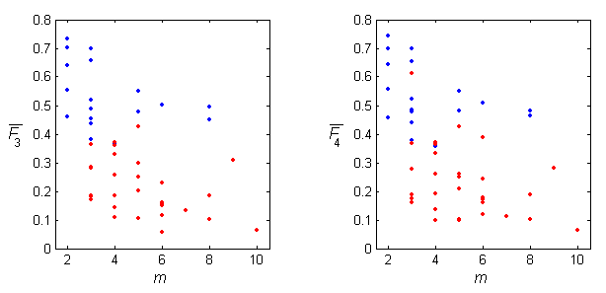

Figure S19. Scatterplot of the number of descriptors in a model (m) versus the average F₃-function ($\overline{F_{3}}$) for the complete dataset (left) or the average F₄-function ($\overline{F_{4}}$) for the training set after data split (right). The 50 models are split into those with (red) and without (blue) the sign change problem, according to classifications in Table S2.

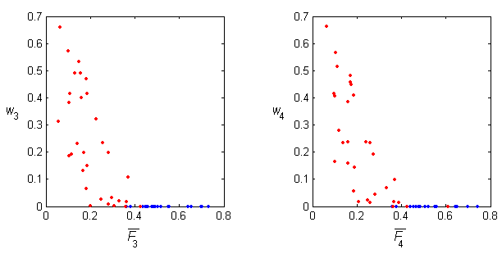

Figure S20. The average F₃-function ($\overline{F_{3}}$) for the complete dataset (left) or the average F₄-function ($\overline{F_{4}}$) for the training set after data split (right) plotted against the respective contributions of the sign-changed coefficients w₃ and w₄. The 50 models are split into those with (red) and without (blue) the sign change problem, according to classifications in Table S2.

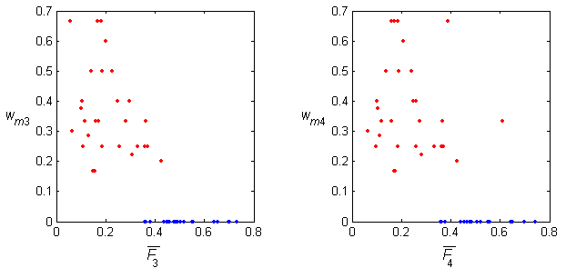

Figure S21. The average F₃-function ($\overline{F_{3}}$) for the complete dataset (left) or the average F₄-function ($\overline{F_{4}}$) for the training set after data split (right) plotted against the respective percentage of the sign-changed descriptors w_{m3} and w_{m4}. The 50 models are split into those with (red) and without (blue) the sign change problem, according to classifications in Table S2.

